PROJECT  
[**MovieLens-Hive-Vs-SQL**](https://github.com/pradeepsalunke/MovieLens-Hive-Vs-SQL)

Dataset

## MovieLens (https://grouplens.org/datasets/movielens/100k/)

* Data set consists of:
  + 100,000 ratings (1-5) from 943 users on 1682 movies.
  + Each user has rated at least 20 movies.
  + Simple demographic info for the users (age, gender, occupation, zip)
* Tables:
  + User (userid, age, gender, occupationid, zipcode)
  + Movie (movieid, title, release_date, genre)
  + Occupation (occupationid, occupation)
  + Zipcode (zipcode, city, state)
  + Data (userid, itemid, rating, timestamp)

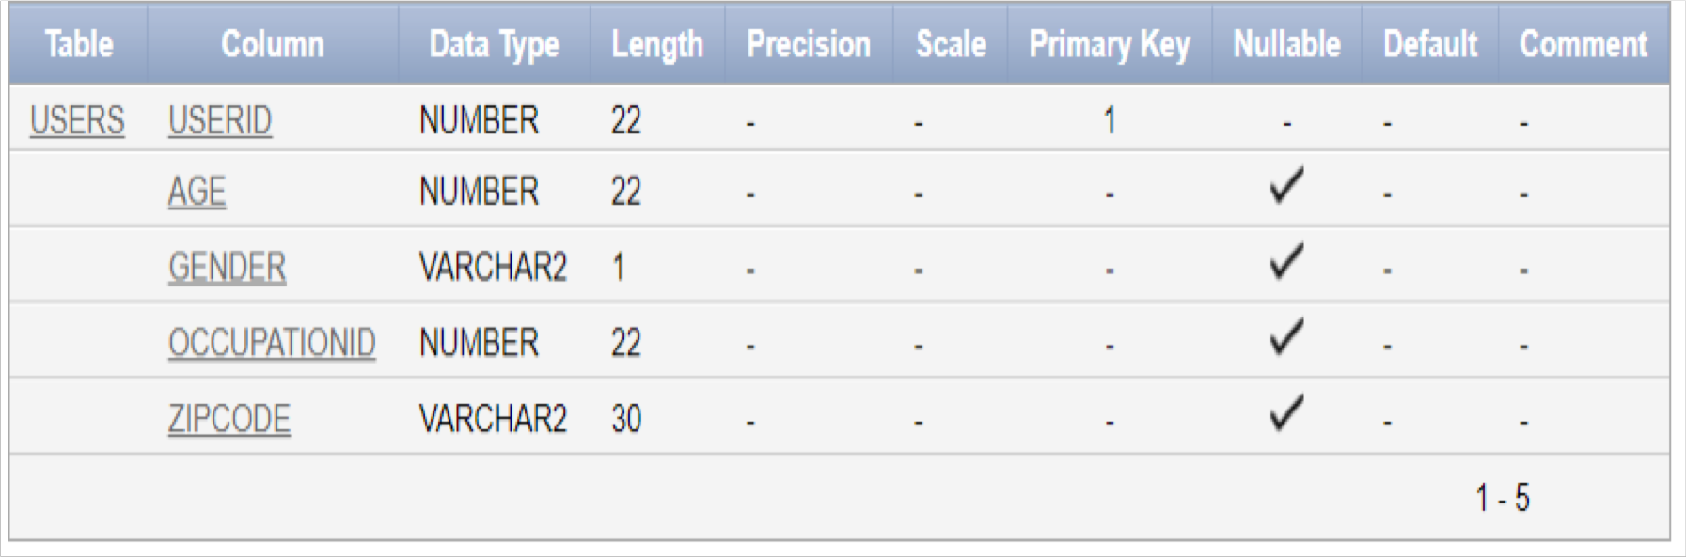 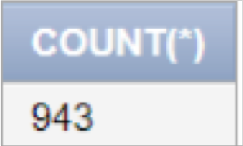

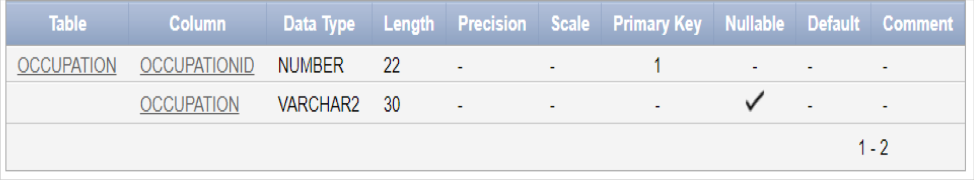

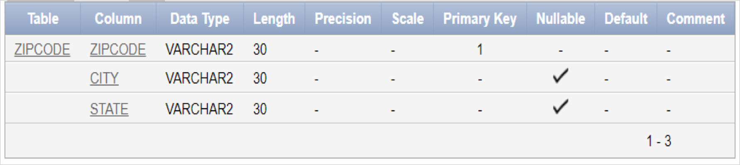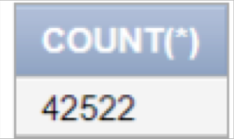

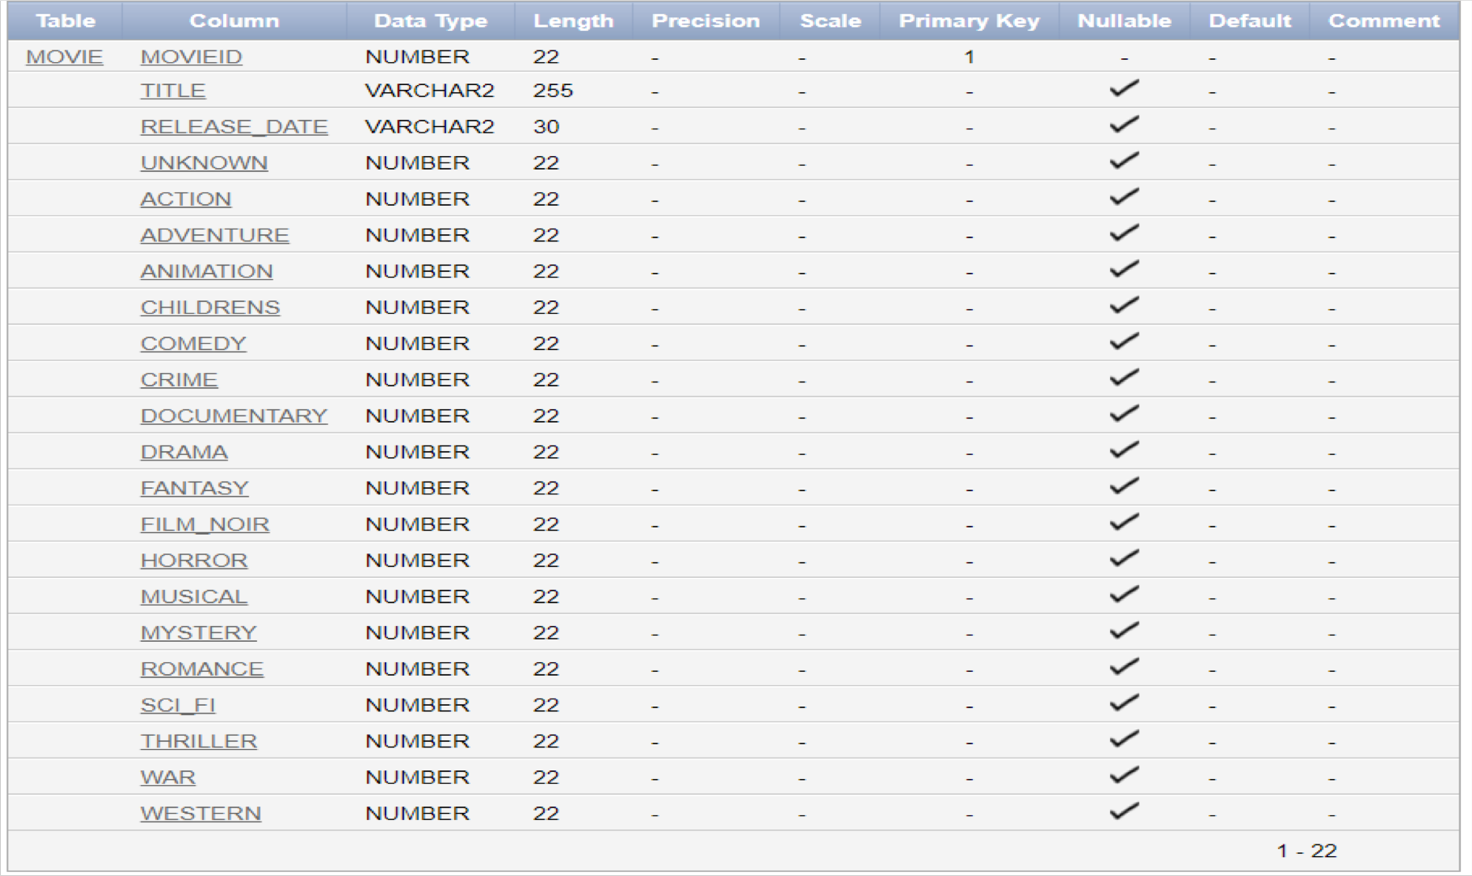 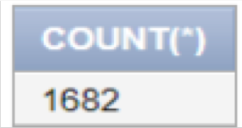

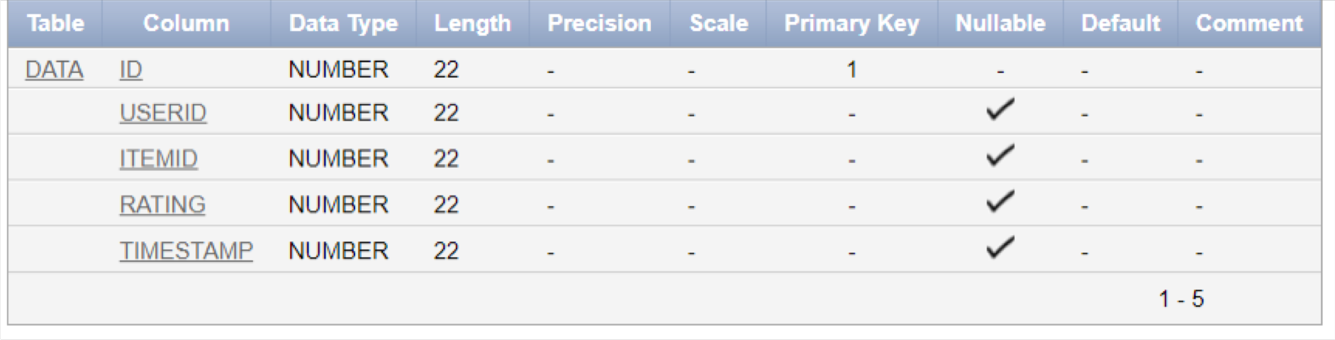

# Data Cleaning

## Removing unnecessary columns

* Removing duplicate rows
* Removing rows that don’t match foreign keys
* Removing commas in string values

Query 1

### Select all the movies under Comedy and Crime genre

SELECT title, release_date FROM movie

WHERE Comedy = 1 AND Crime = 1

**Results:**

**Rows fetched : 16 Oracle : 0.00 seconds Hive: 11.368 seconds**

Oracle and Hive query results

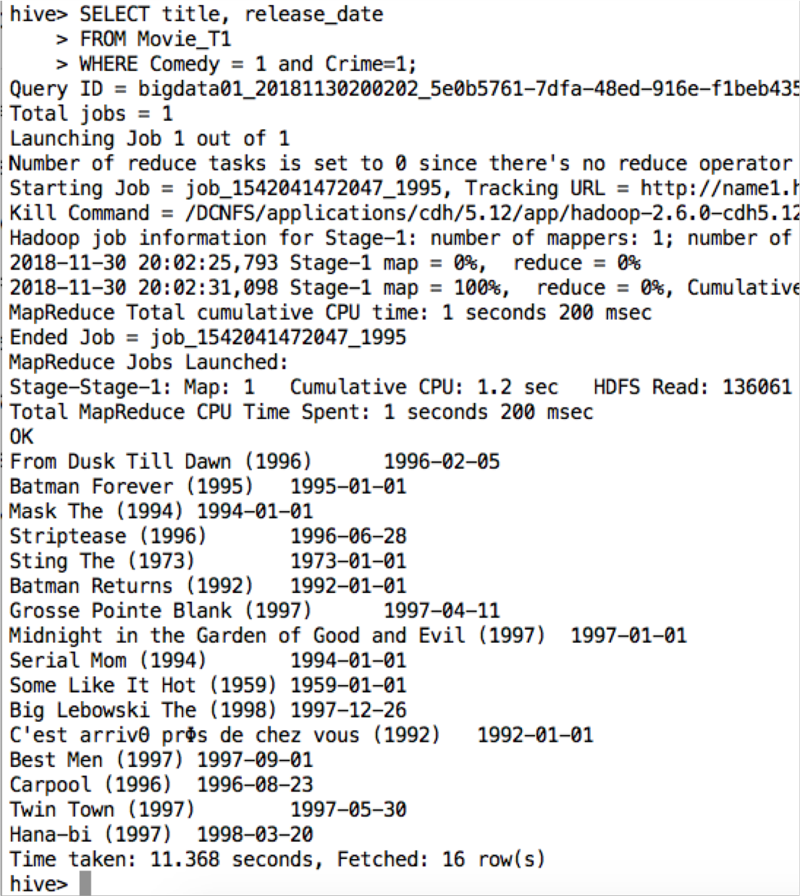

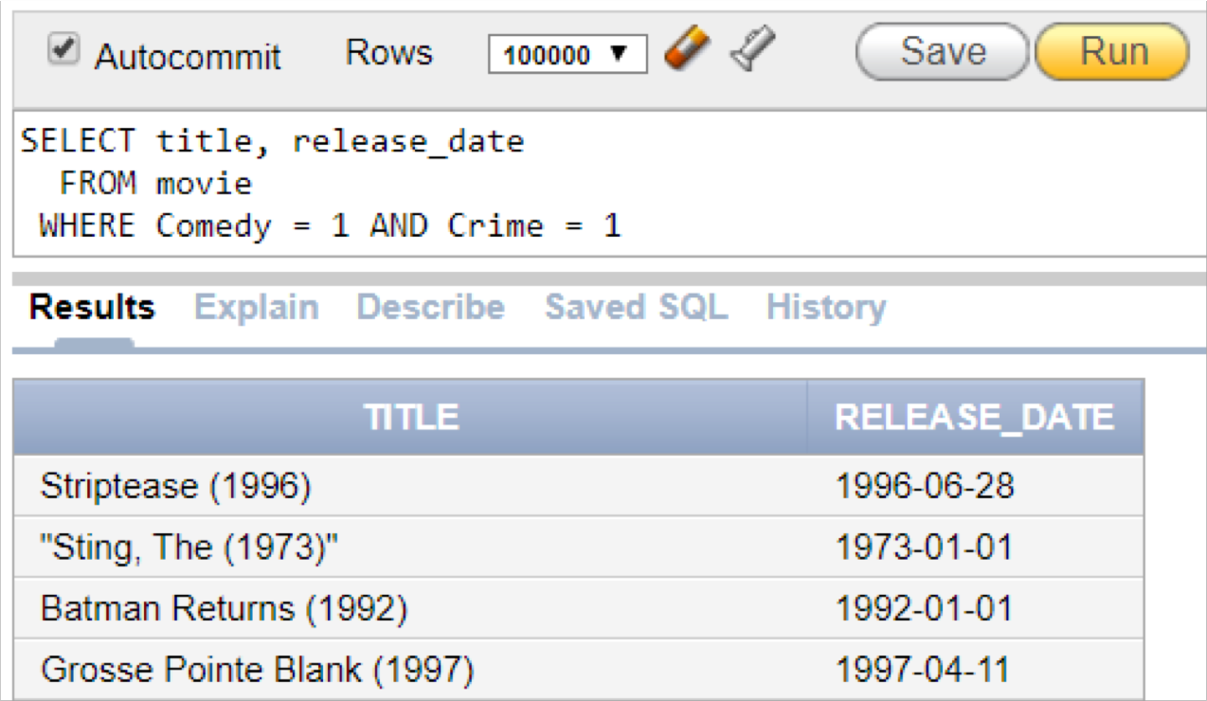

Oracle Explain Plan for Query 1

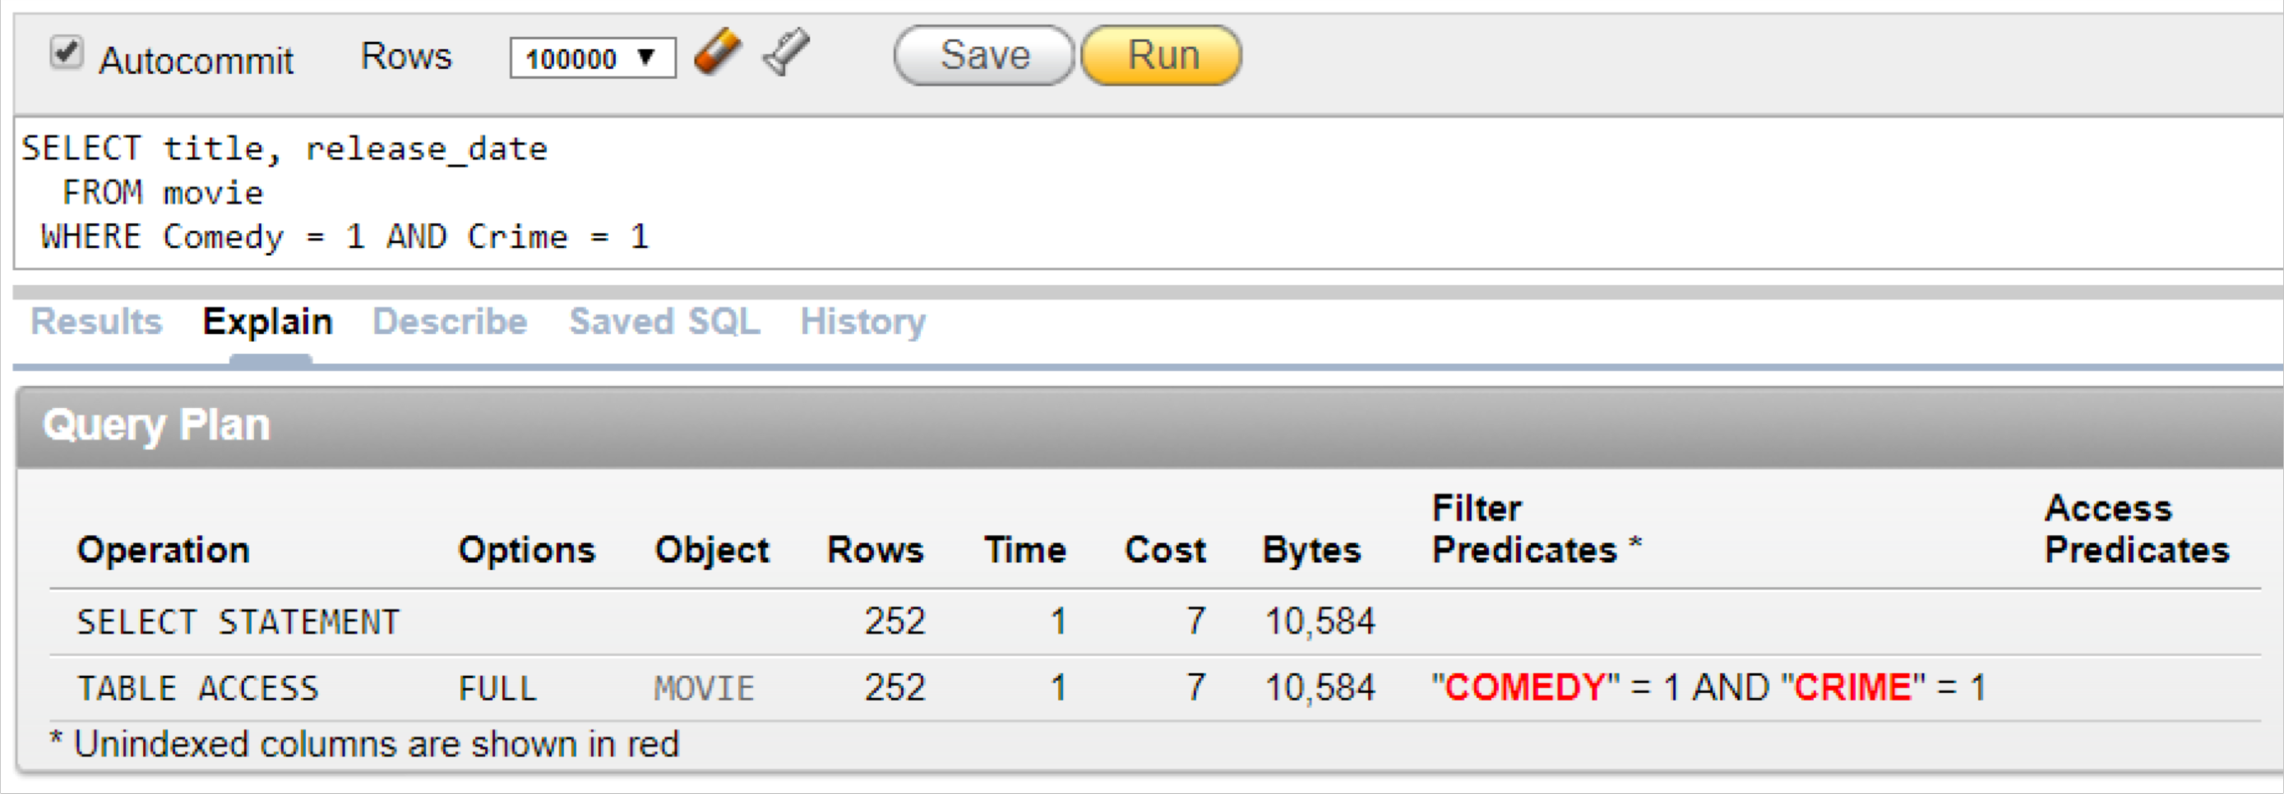

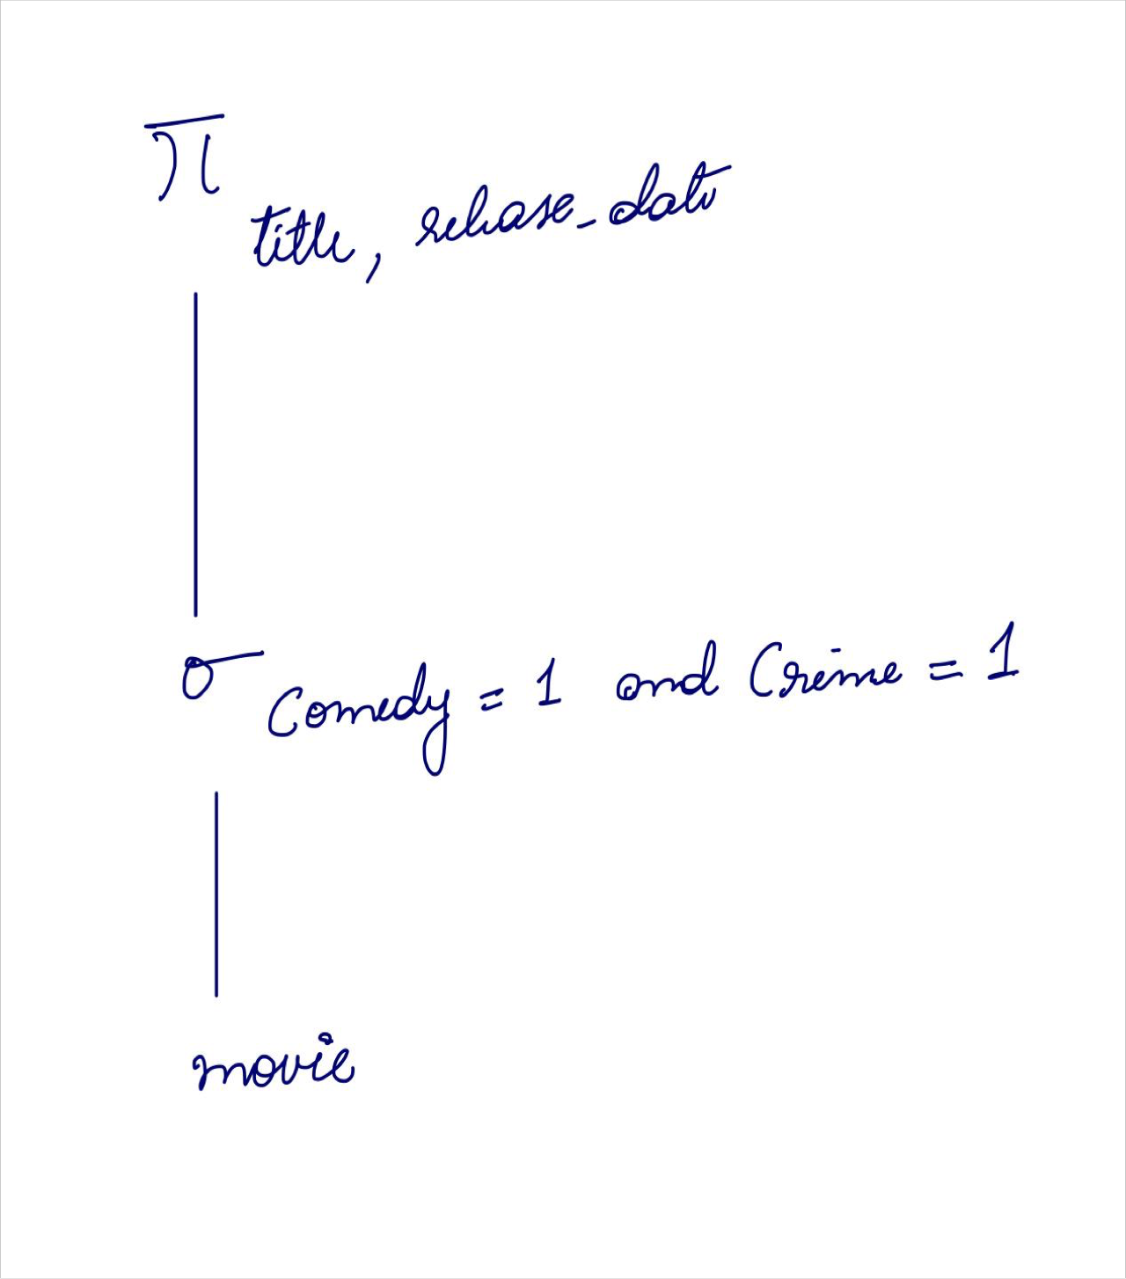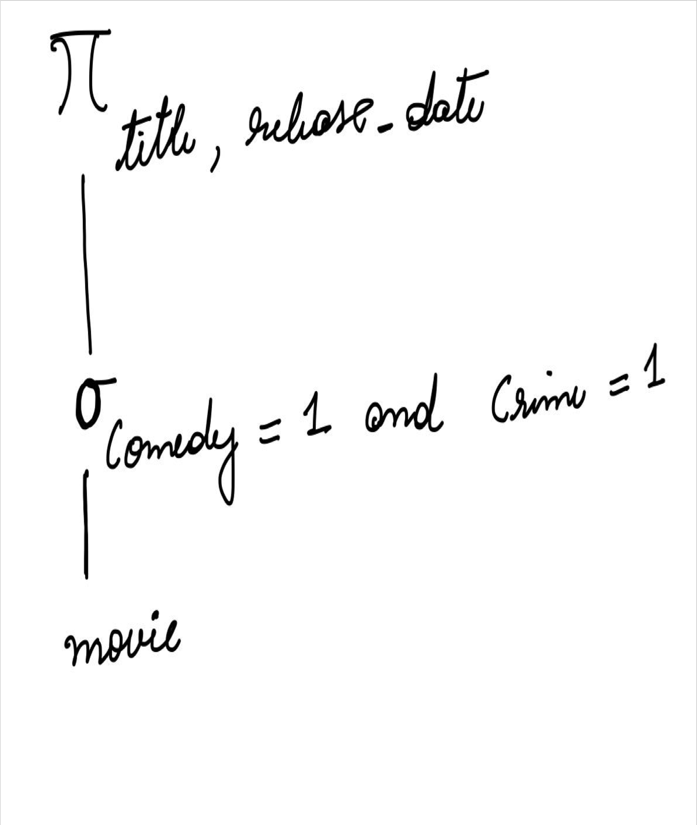**Our Explain Plan Oracle’s Explain Plan**

Query 2

***Most popular movies among women***

SELECT m.movieid, m.title FROM movie m

INNER JOIN (

SELECT d.userid, d.itemid, d.rating FROM data d

INNER JOIN (

SELECT userid, gender FROM users

WHERE gender = 'F') f ON d.userid = f.userid WHERE d.rating = 5) d

ON m.movieid = d.itemid

**Result:**

**Rows fetched: 5975**

**Oracle : 0.09 seconds Hive : 28.04 seconds**

Oracle and Hive query results

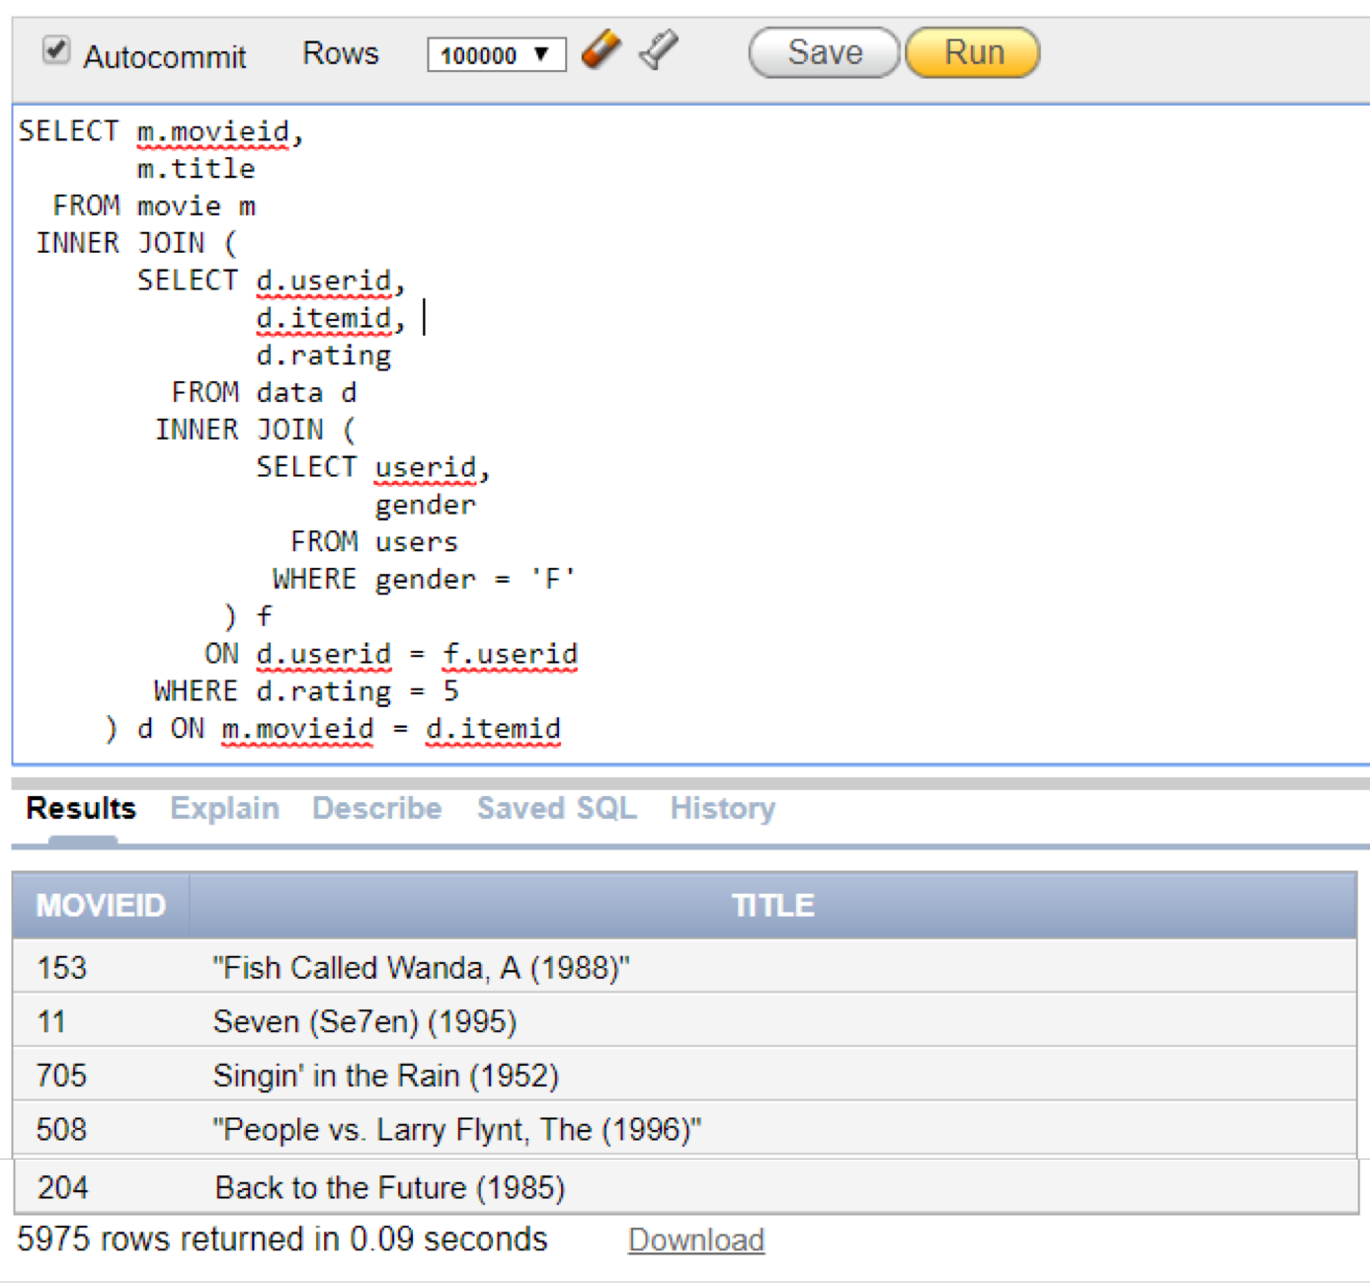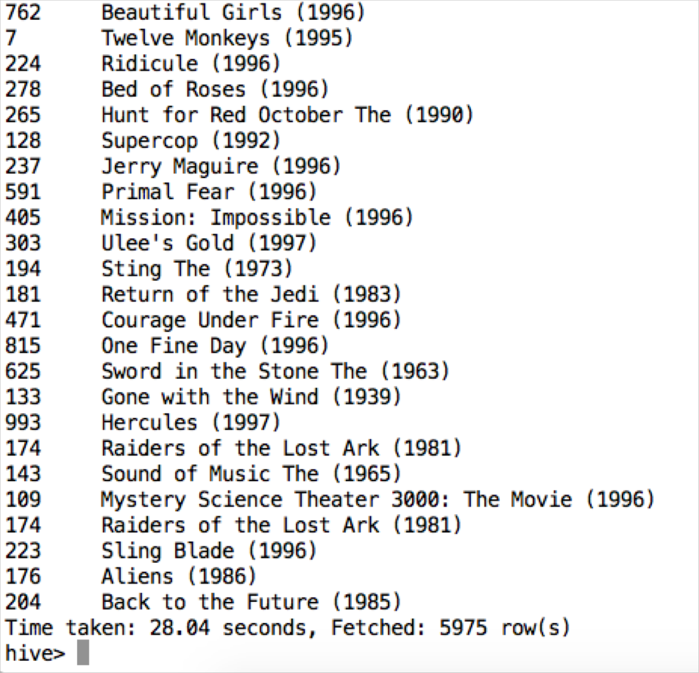

Oracle Explain Plan for Query 2

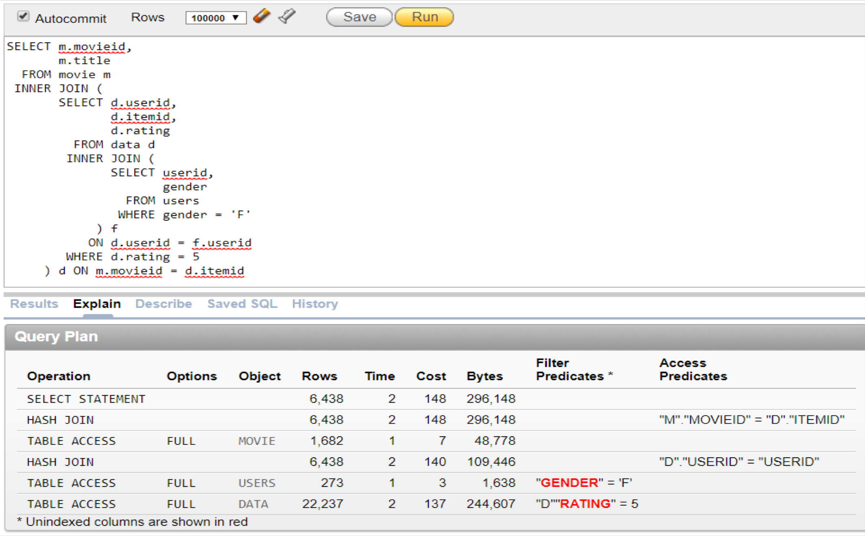

**Our Explain Plan Oracle’s Explain Plan**

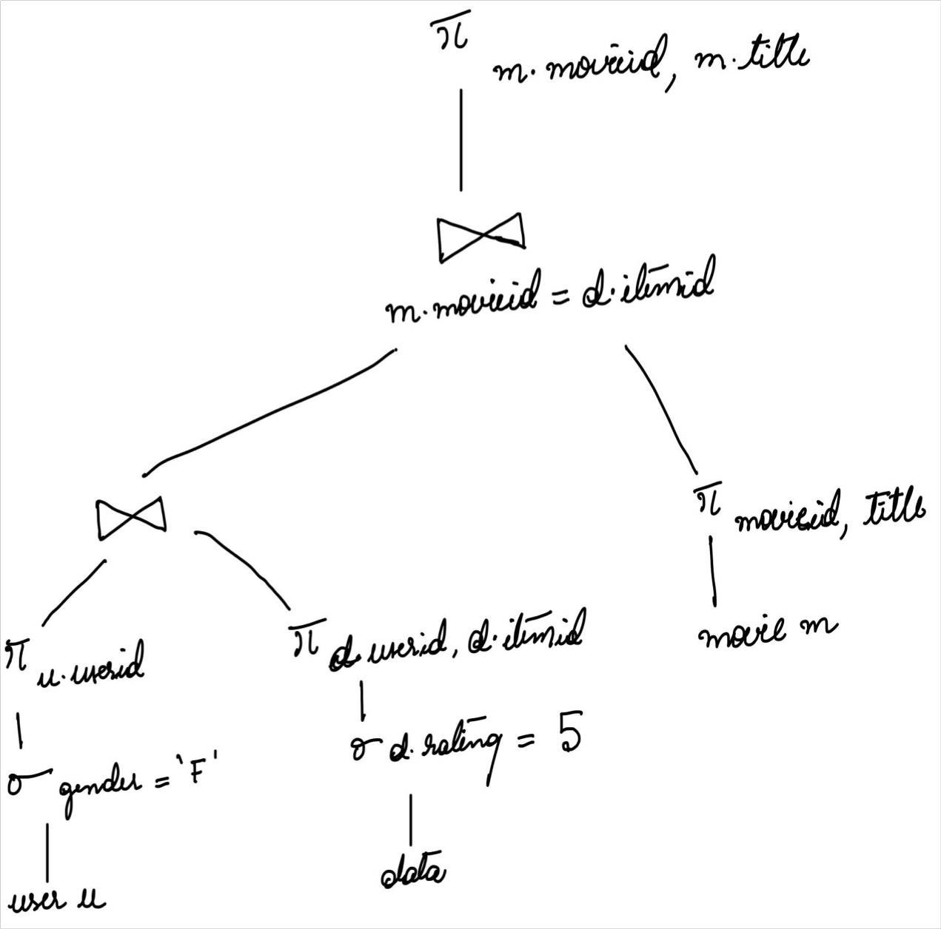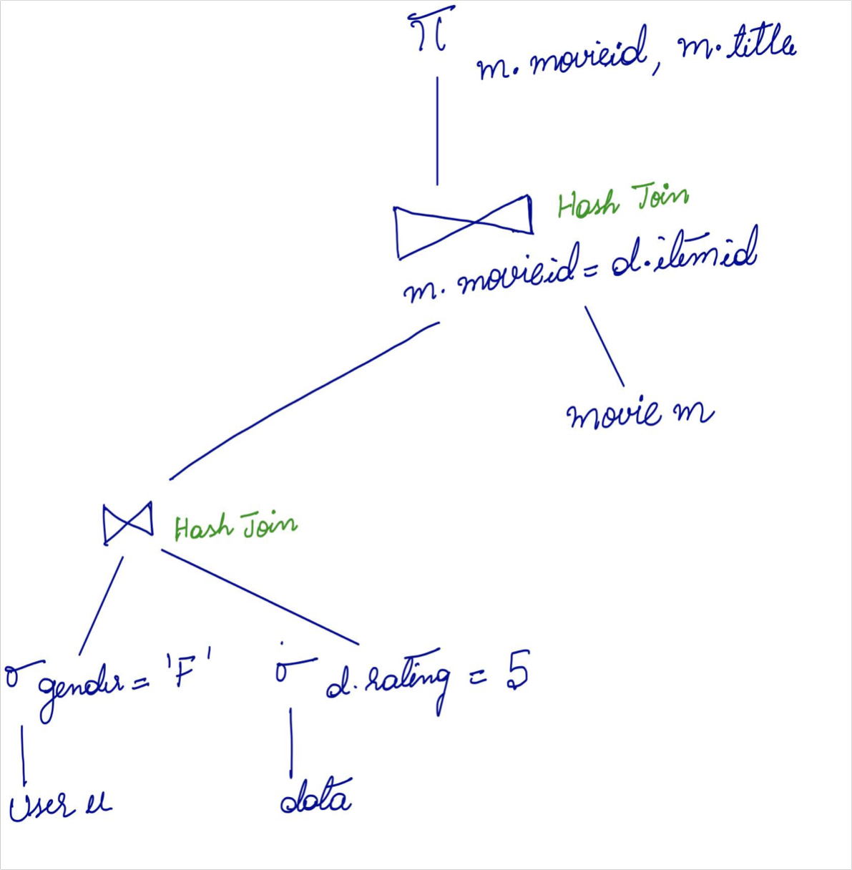

Query 3

***Average movie rating for each gender***

SELECT u.gender, avg(d.rating) AS avg_rating FROM users u

INNER JOIN data d

ON u.userid = d.userid GROUP BY u.gender;

**Result:**

**Rows fetched : 2 Oracle : 0.04 seconds Hive : 39.7 seconds**

Oracle and Hive query results

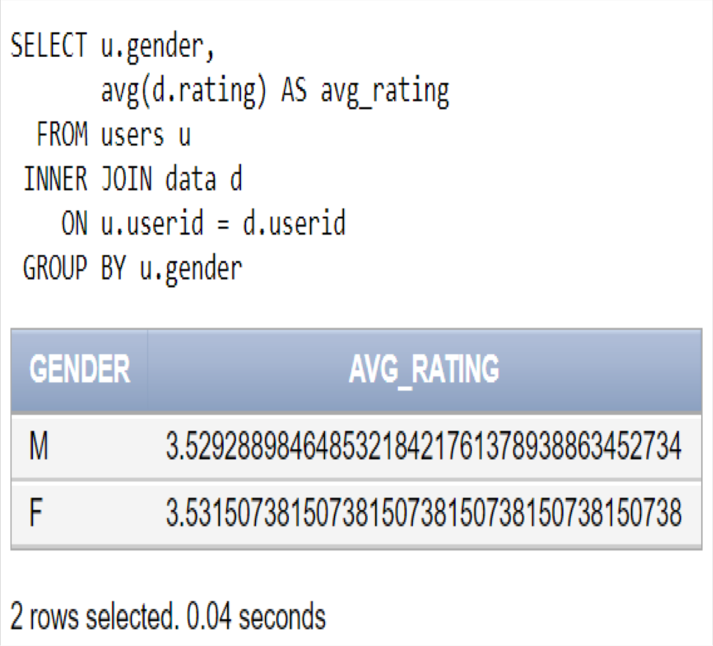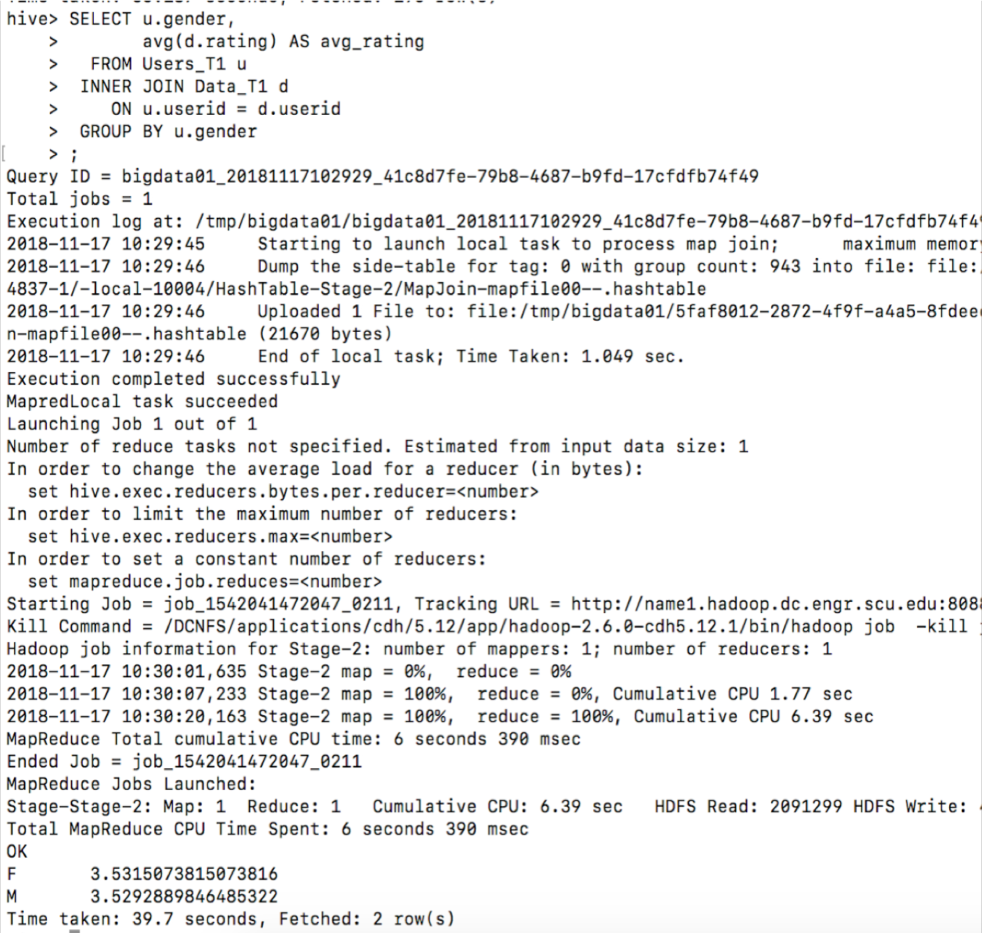

Oracle Explain Plan for Query 3

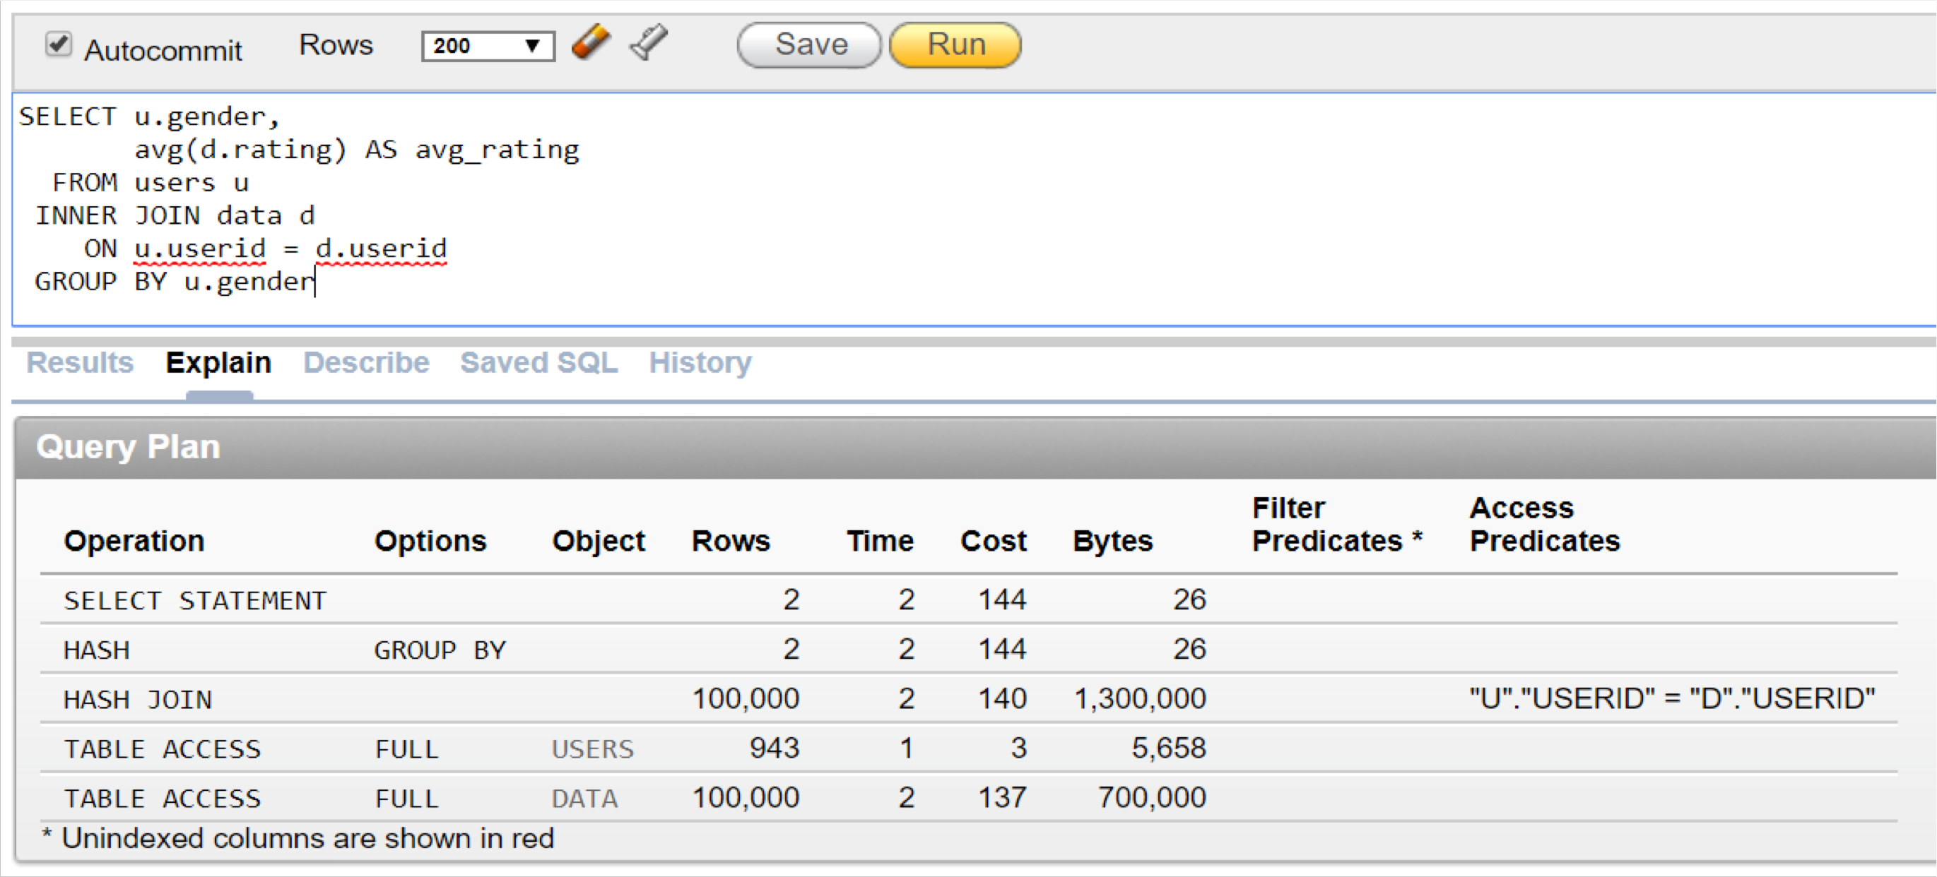

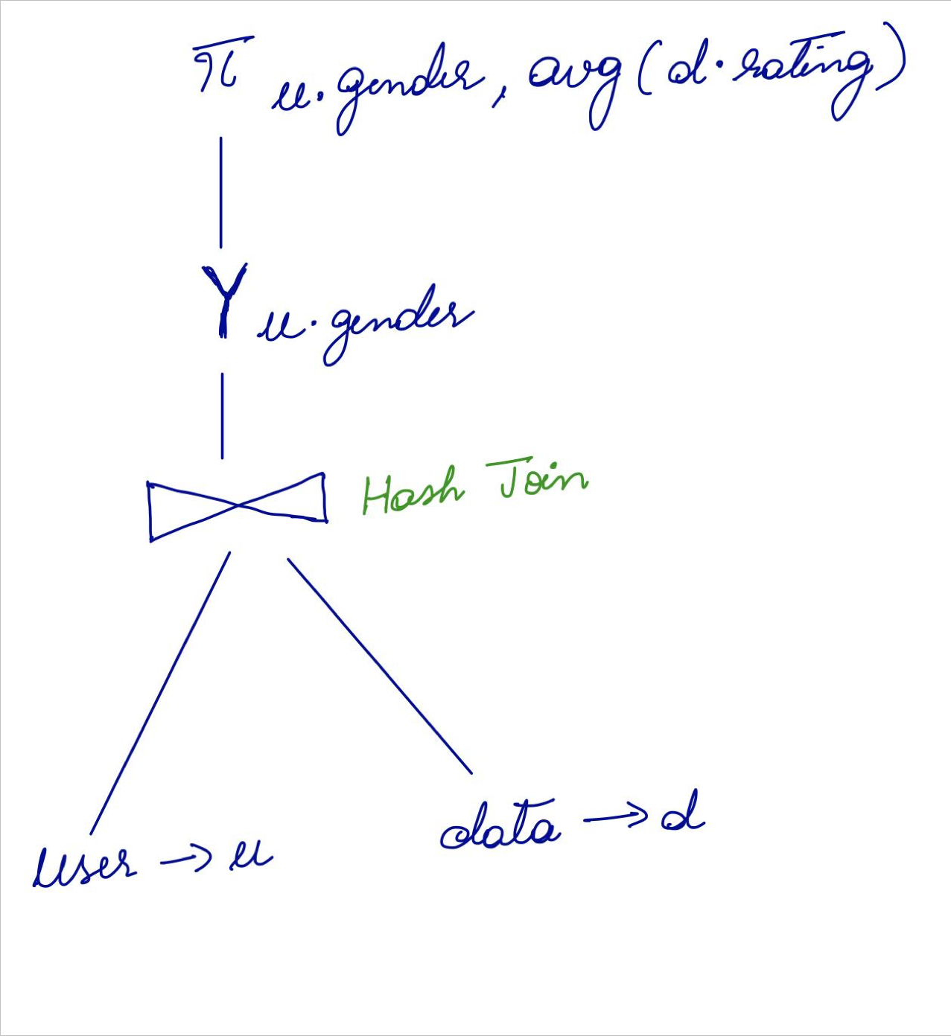**Our Explain Plan Oracle’s Explain Plan**

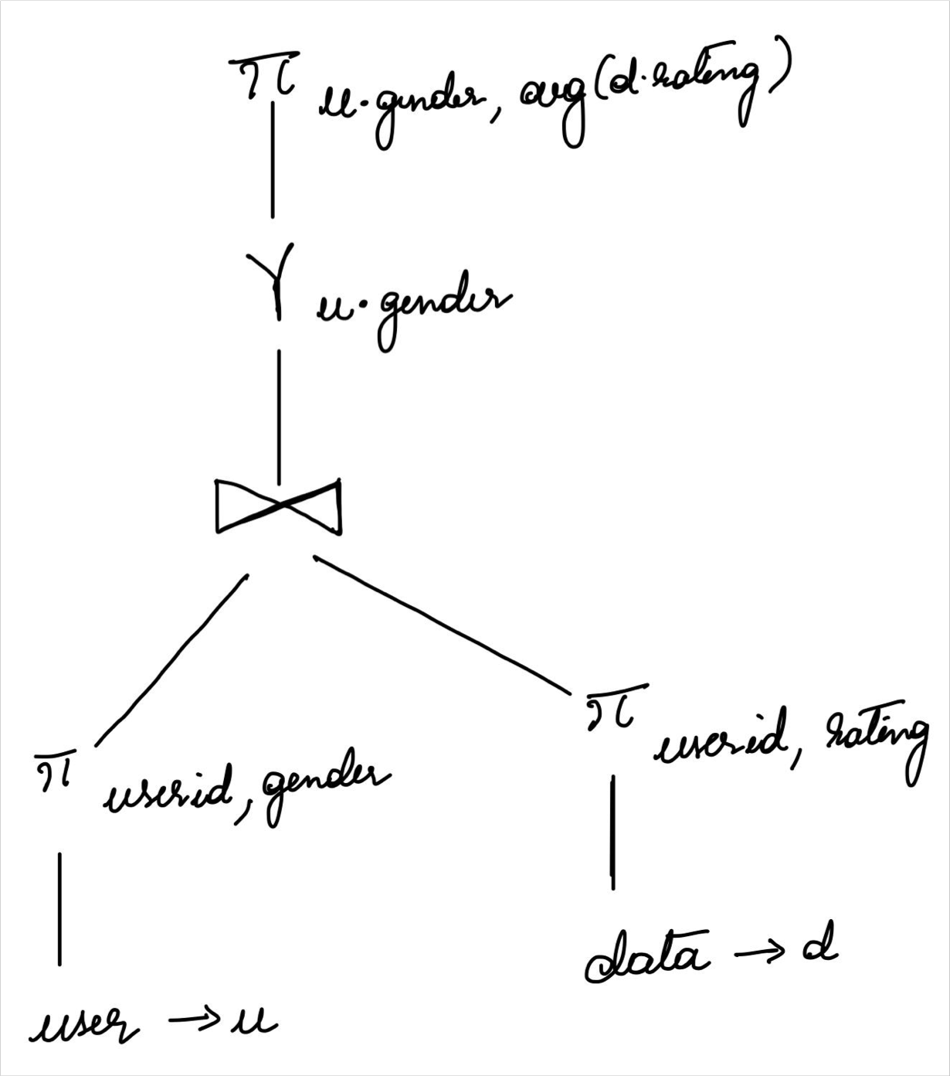

Query 4

***Average rating of movies***

SELECT m.title, avg(d.rating) AS avg_rating FROM data d

INNER JOIN movie m

ON movieid = itemid GROUP BY m.title;

**Result:**

**Rows fetched: 1664 rows Oracle : 0.06 seconds Hive : 33.27 seconds**

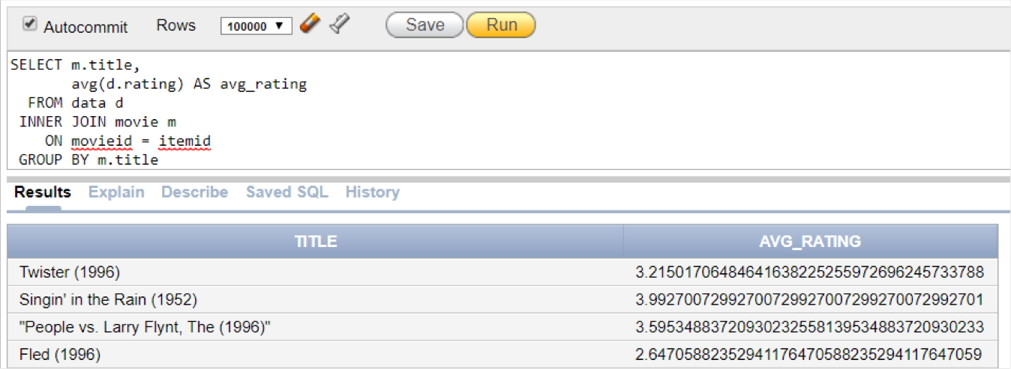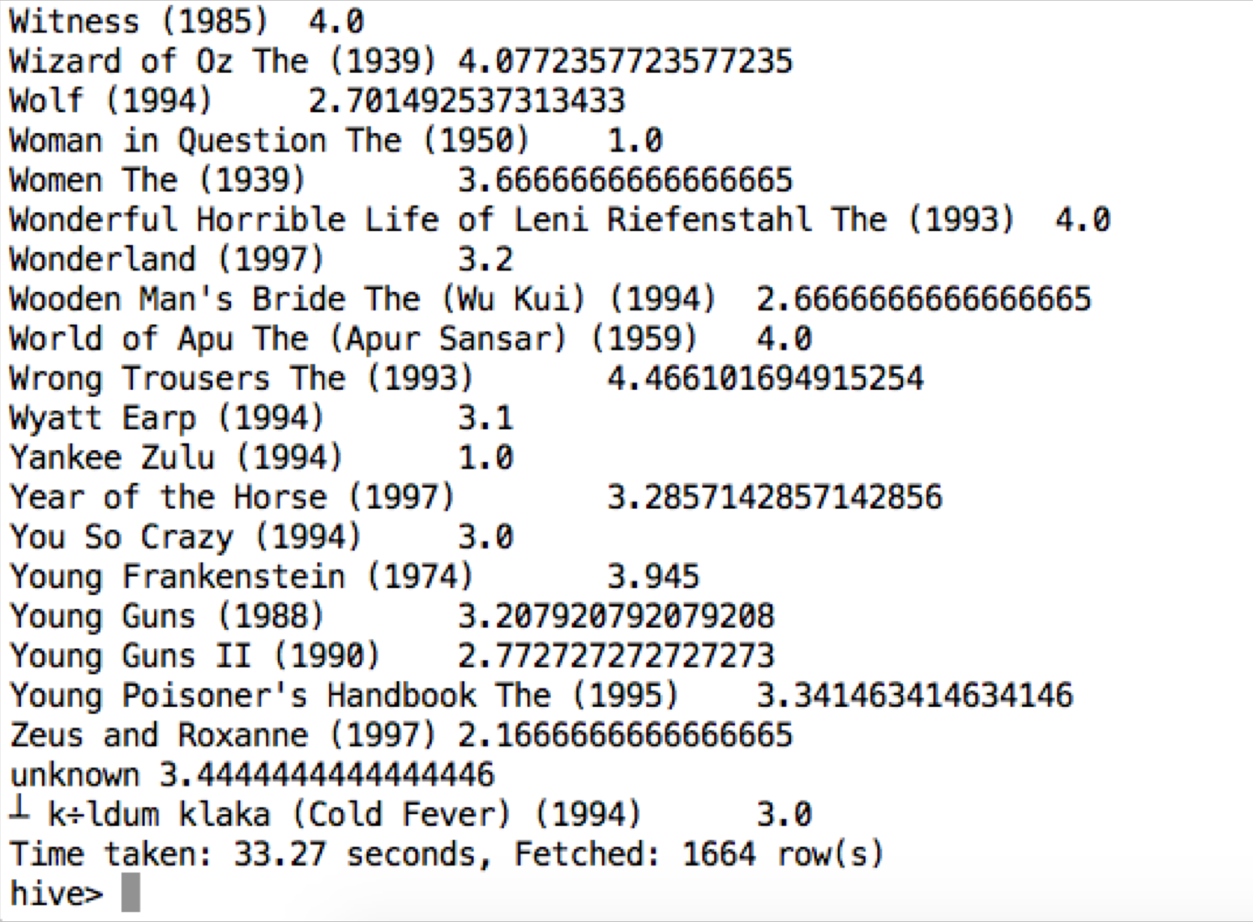Oracle and Hive query results

Oracle Explain Plan for Query 4

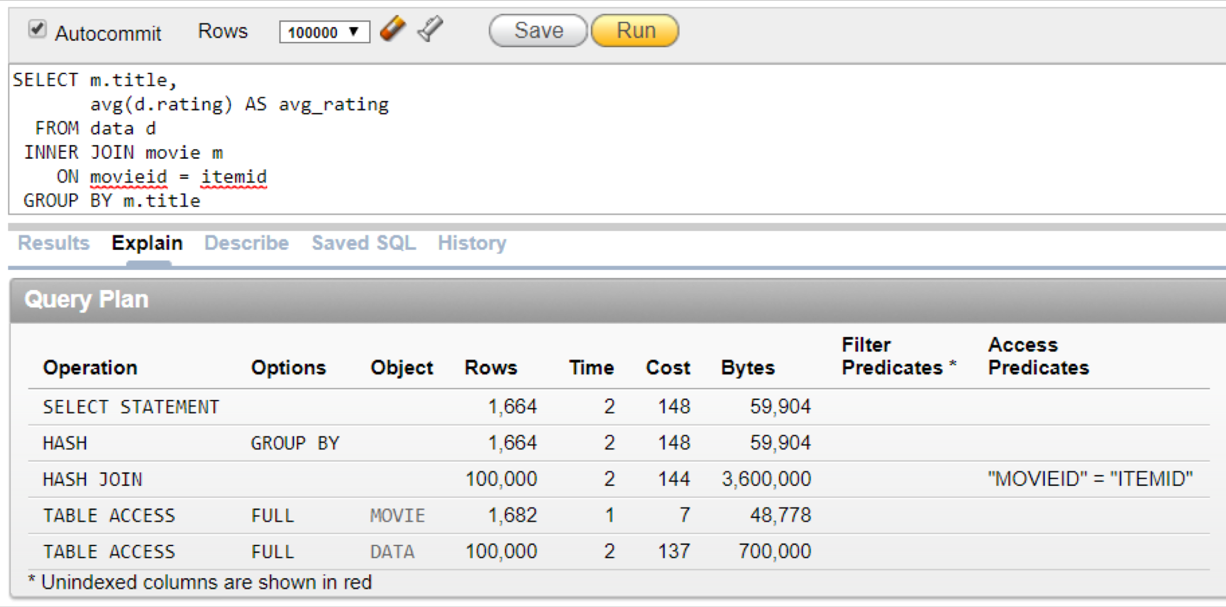

**Our Explain Plan Oracle’s Explain Plan**

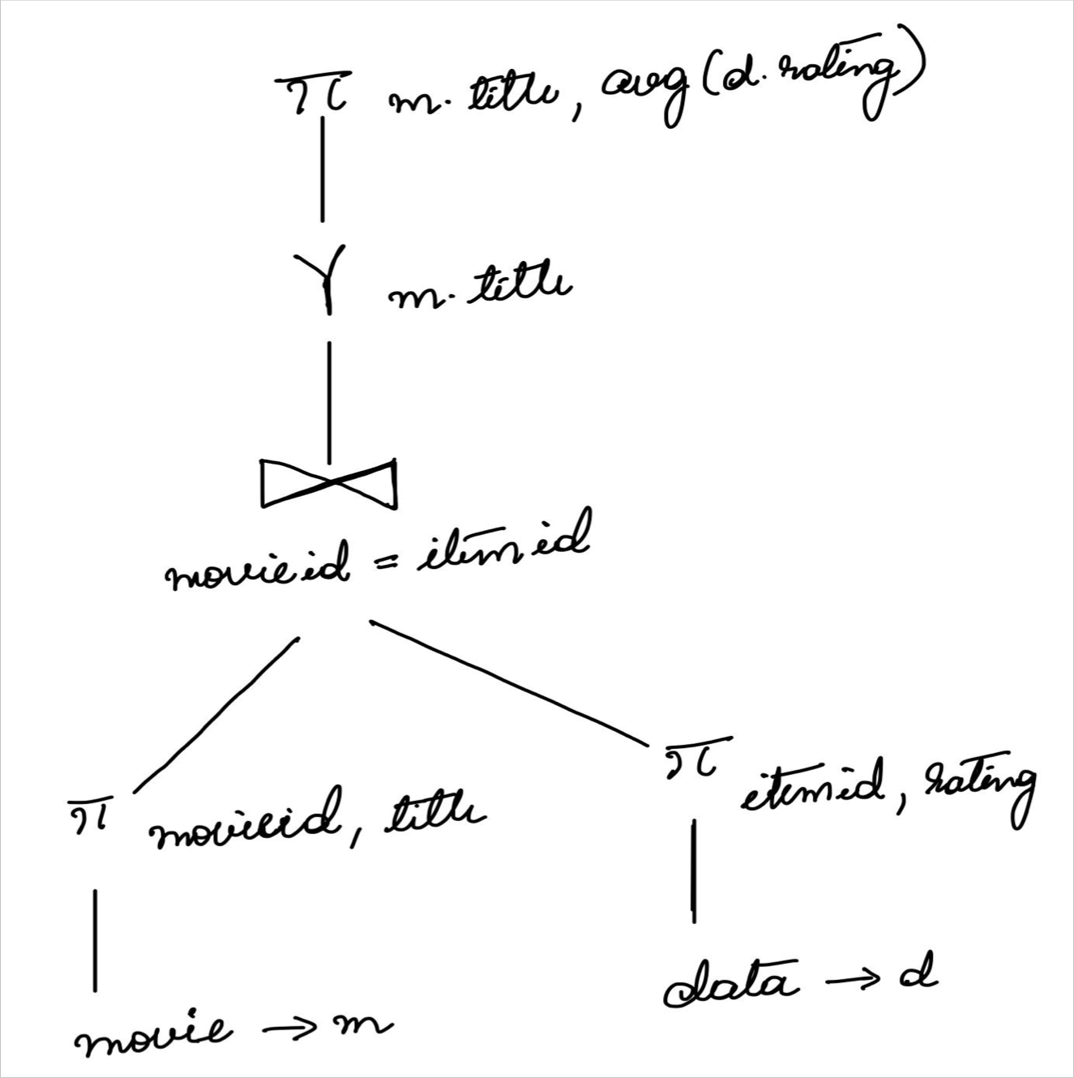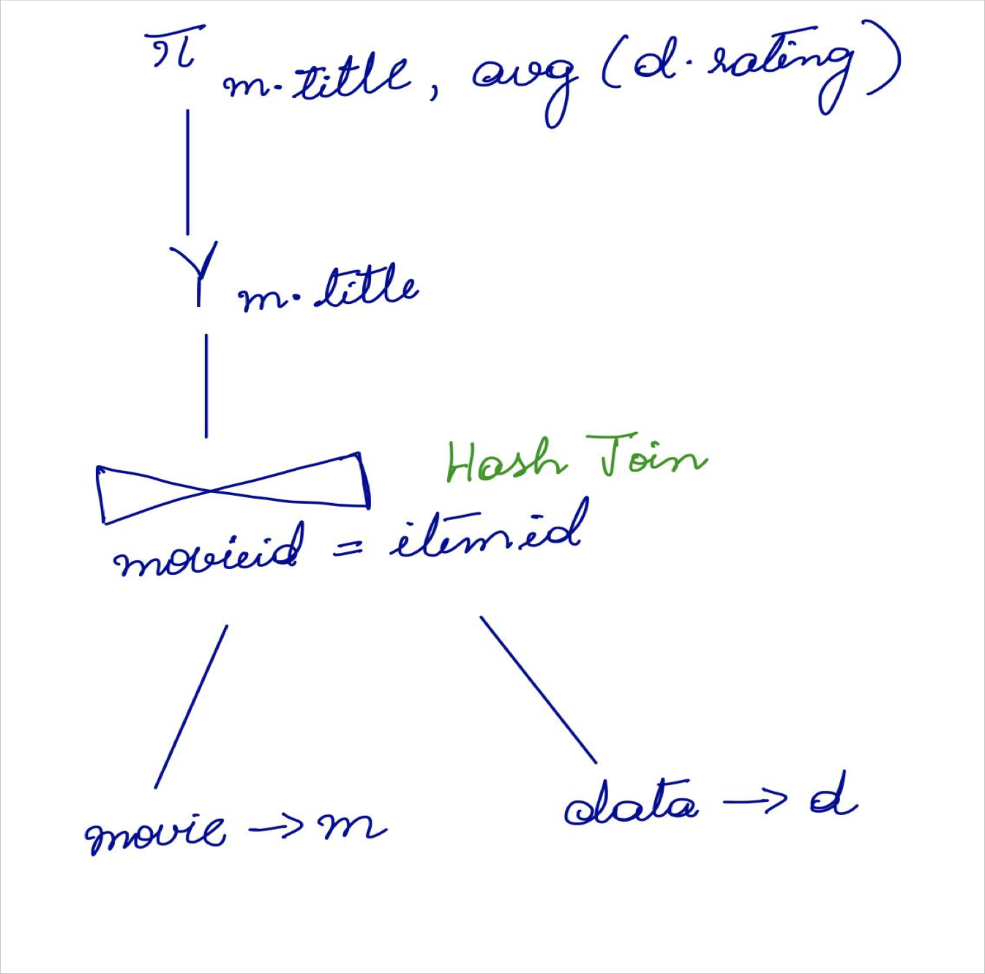

Query 5

***Full information about our users***

SELECT u.*, z.city, z.state FROM users u

LEFT JOIN zipcode z

ON z.zipcode = u.zipcode

**Result:**

**Rows fetched : 943 Oracle : 0.14 seconds Hive : 36.393 seconds**

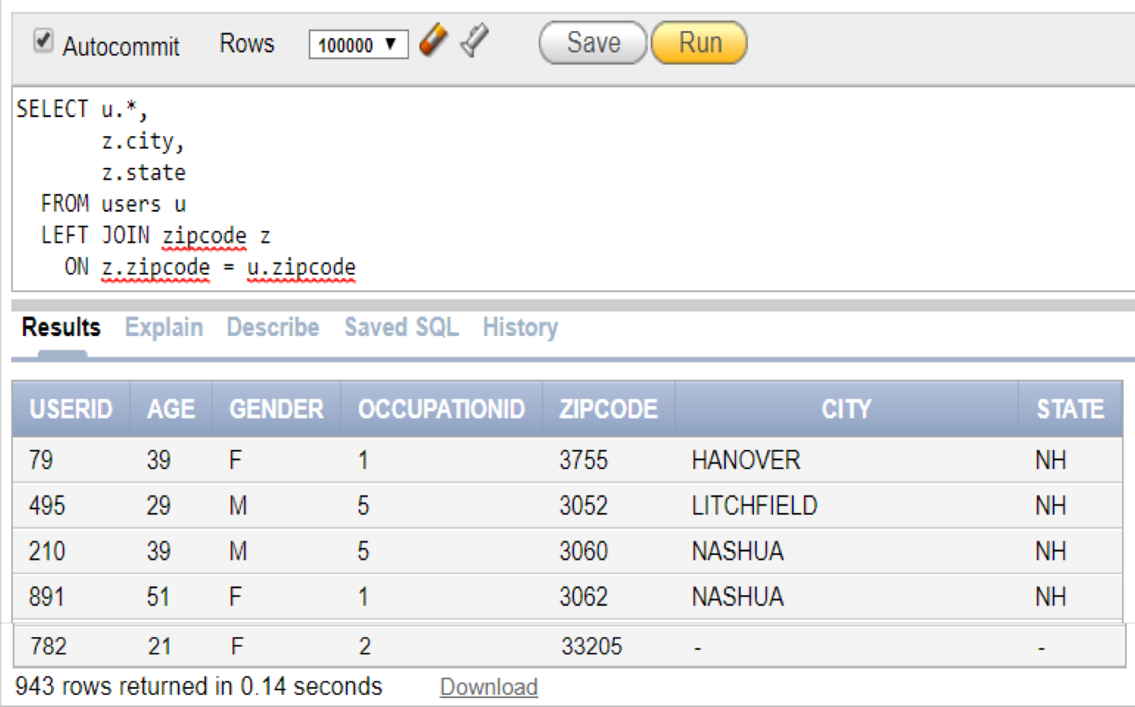Oracle and Hive query result

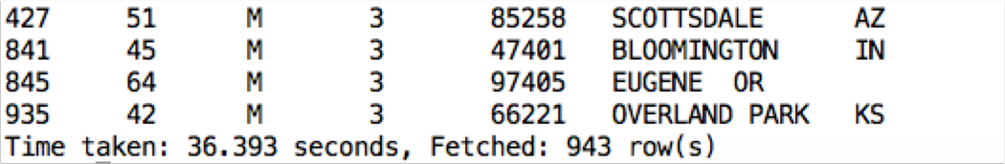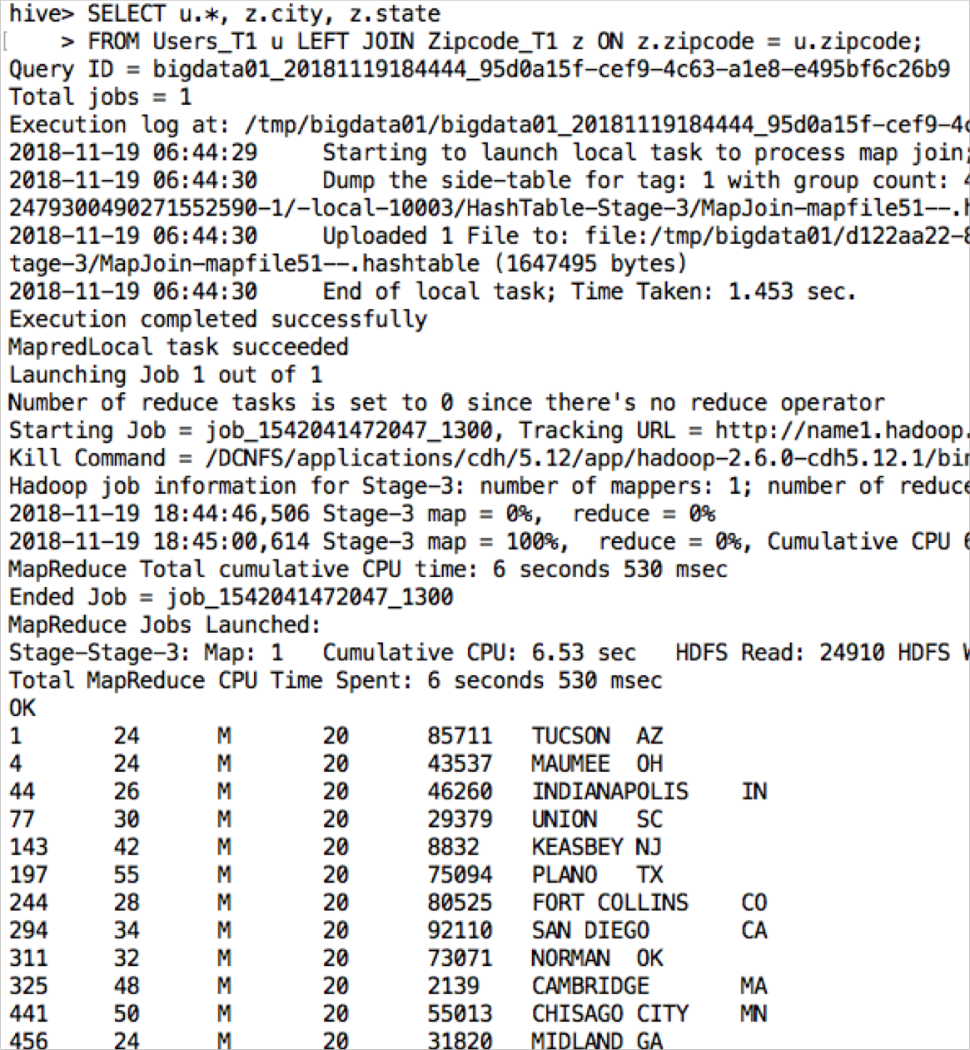

Oracle Explain plan for query 5

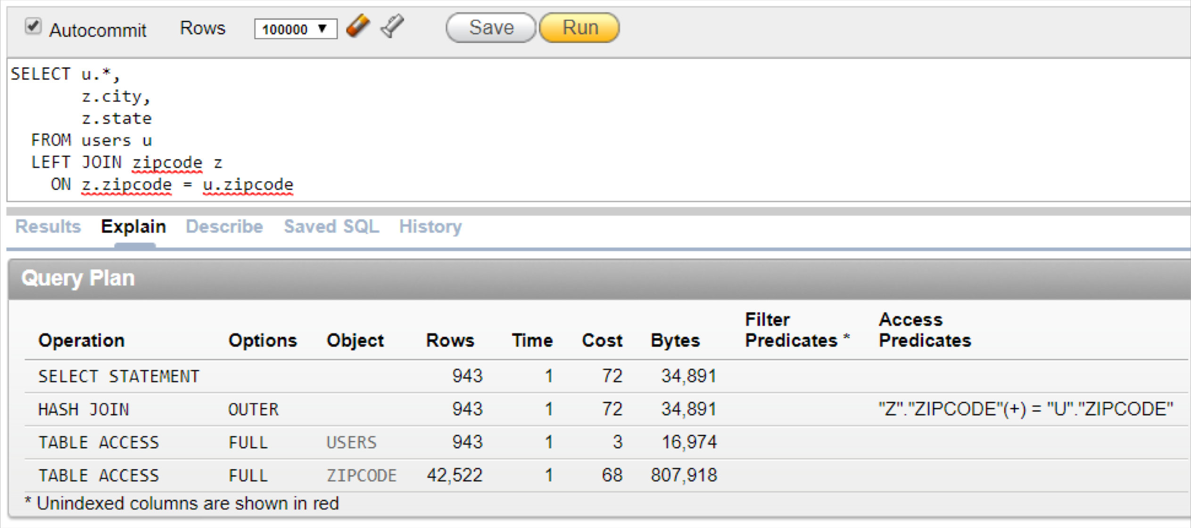

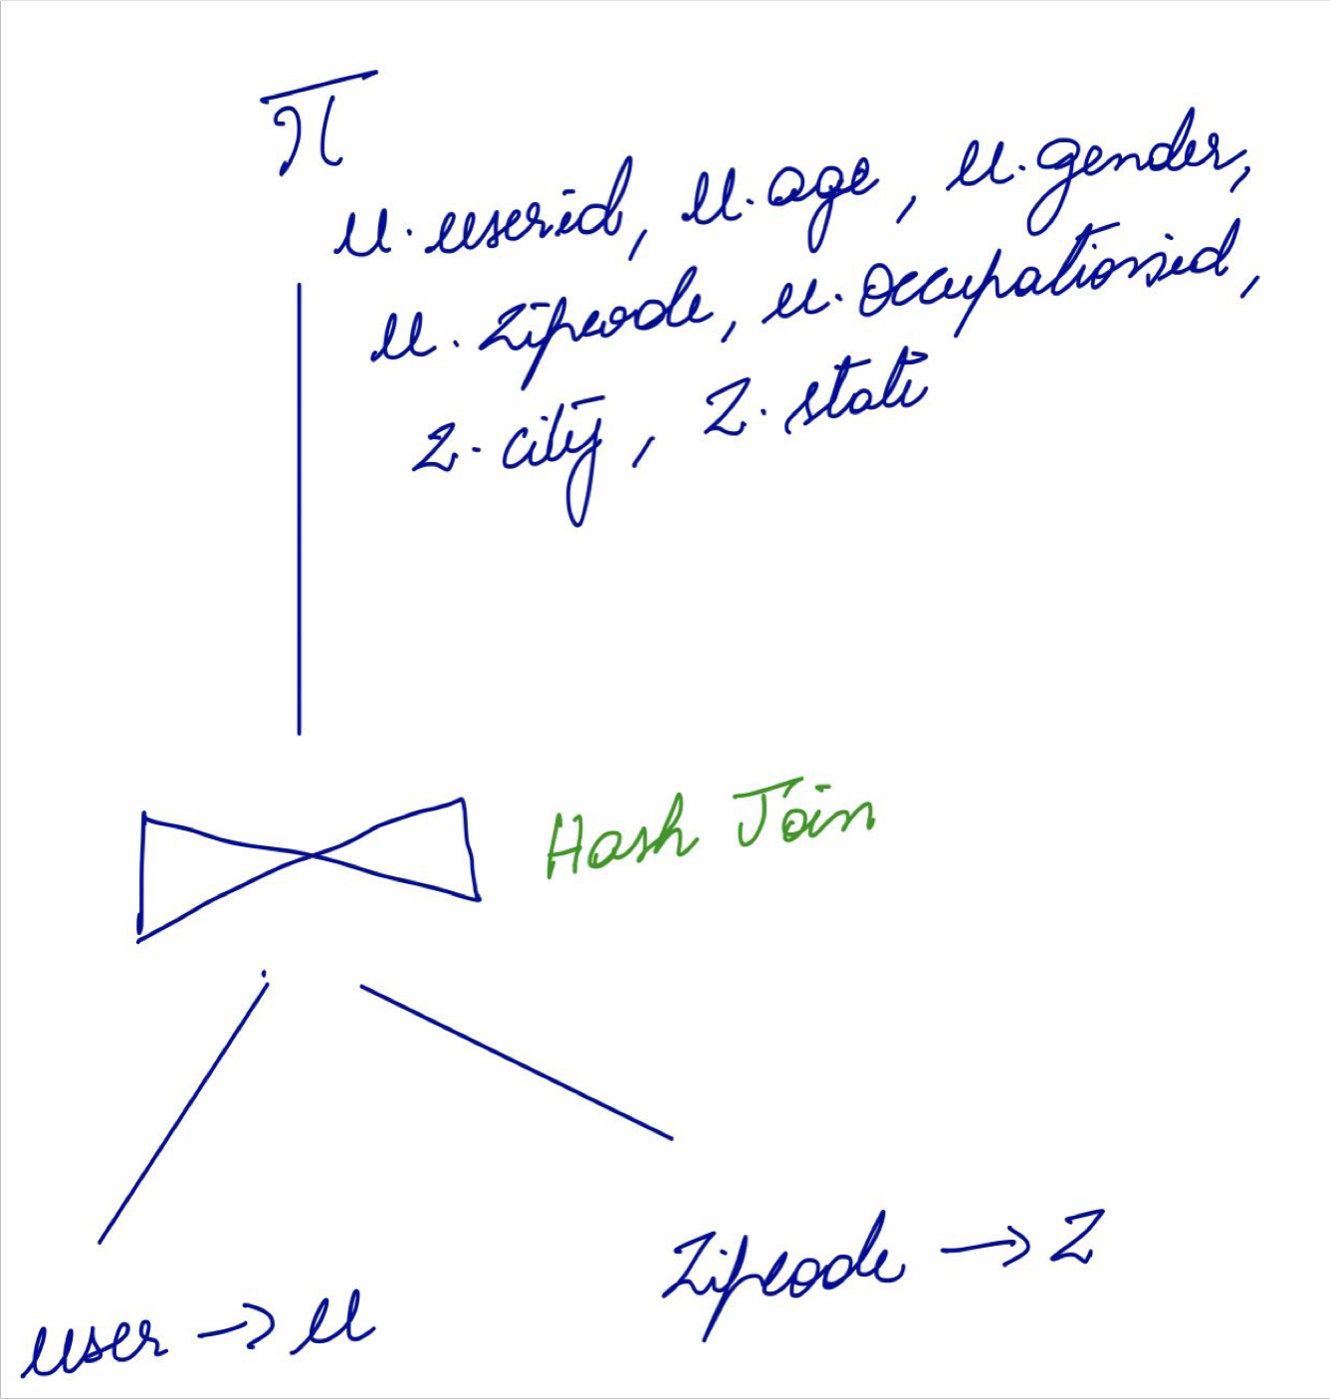**Our Explain Plan Oracle’s Explain Plan**

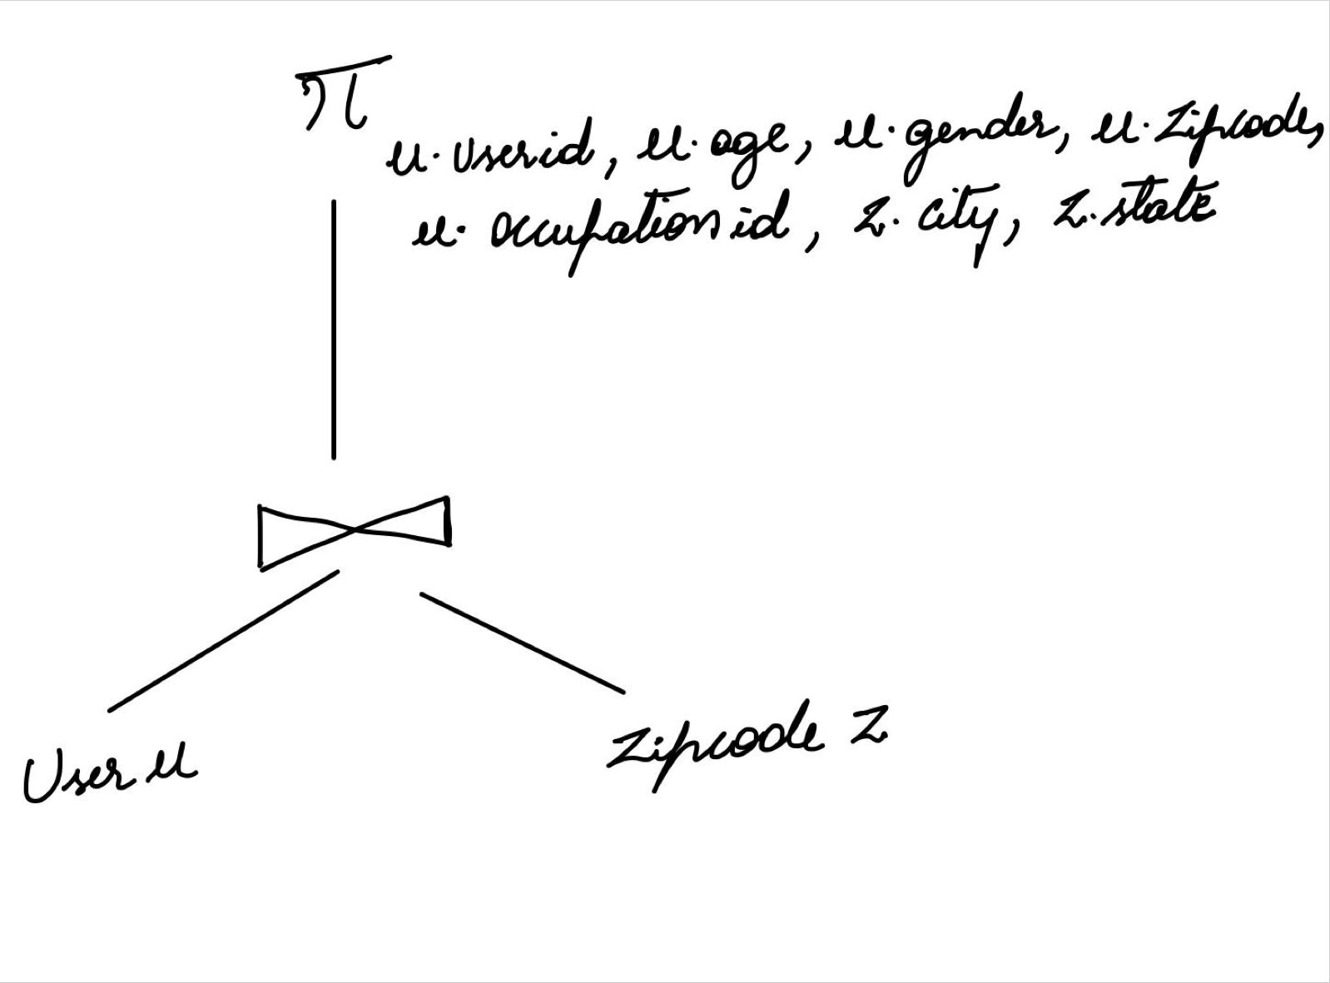

Query 6

***Average rating by occupation***

SELECT o.occupation, avg(d.rating) FROM users u

INNER JOIN data d ON u.userid = d.userid

INNER JOIN occupation o ON u.occupationid = o.occupationid GROUP BY o.occupation

**Result:**

**Rows fetched: 21**

**Oracle: 0.15 seconds**

**Hive: 41.735 seconds**

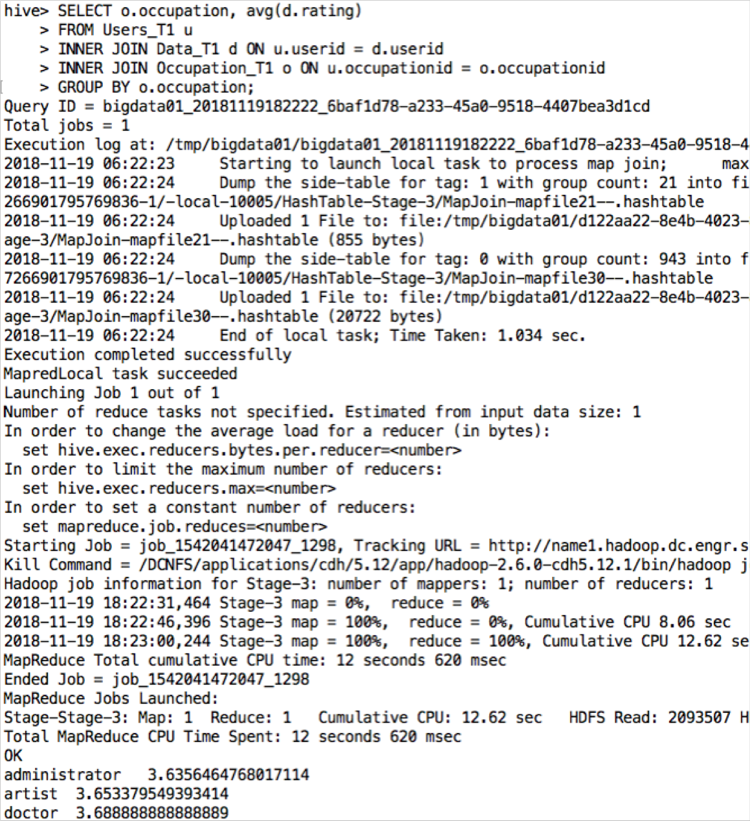Oracle and Hive query results

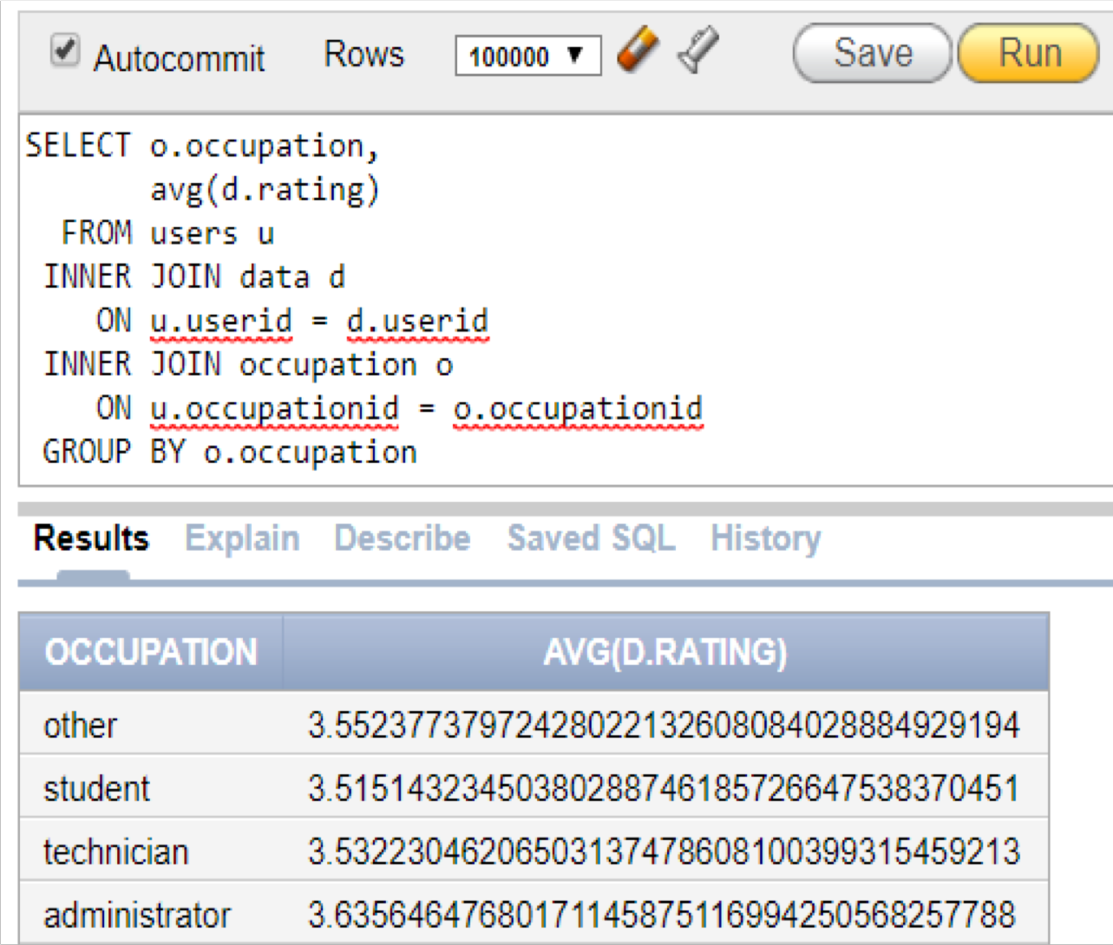

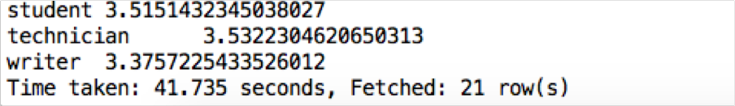

Oracle Explain plan for Query 6

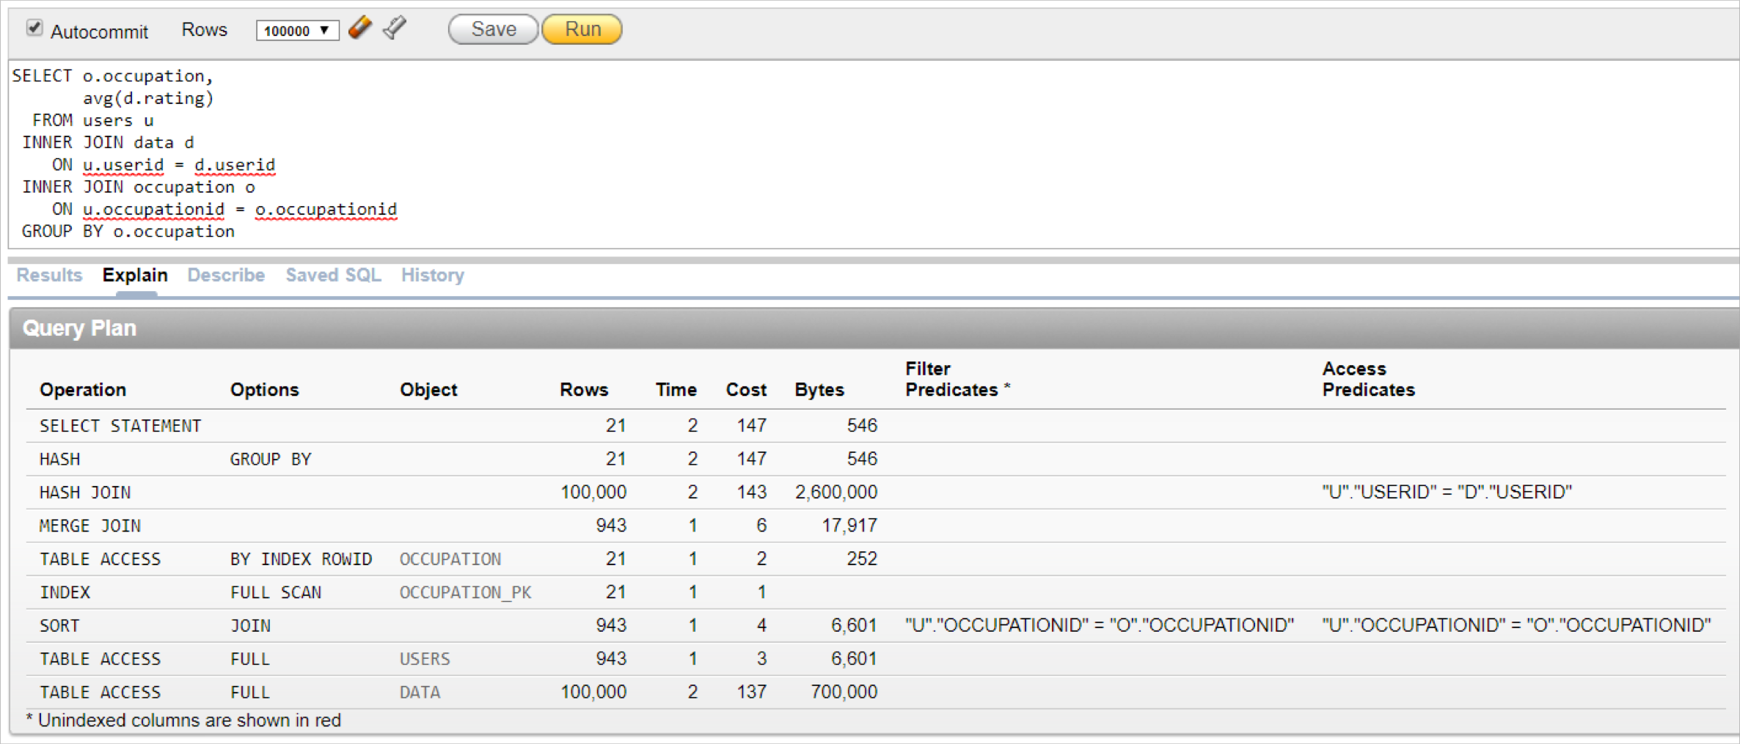

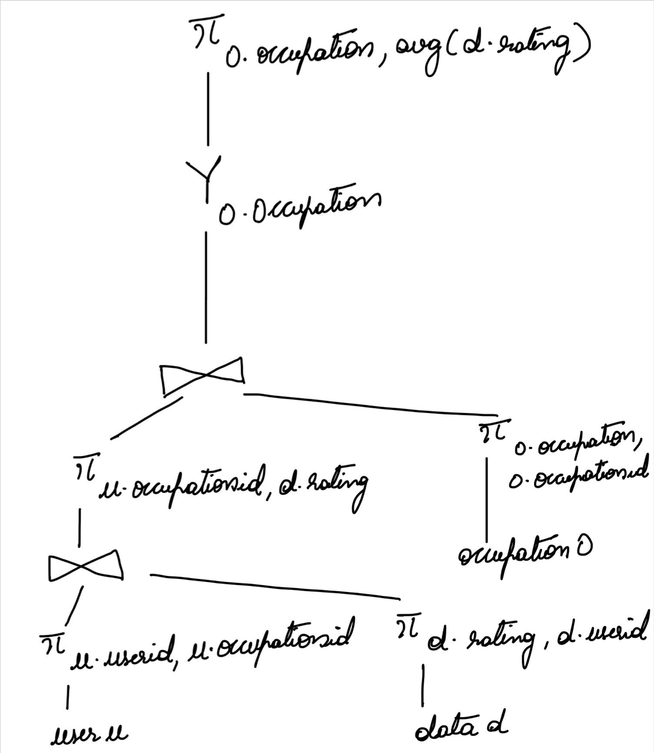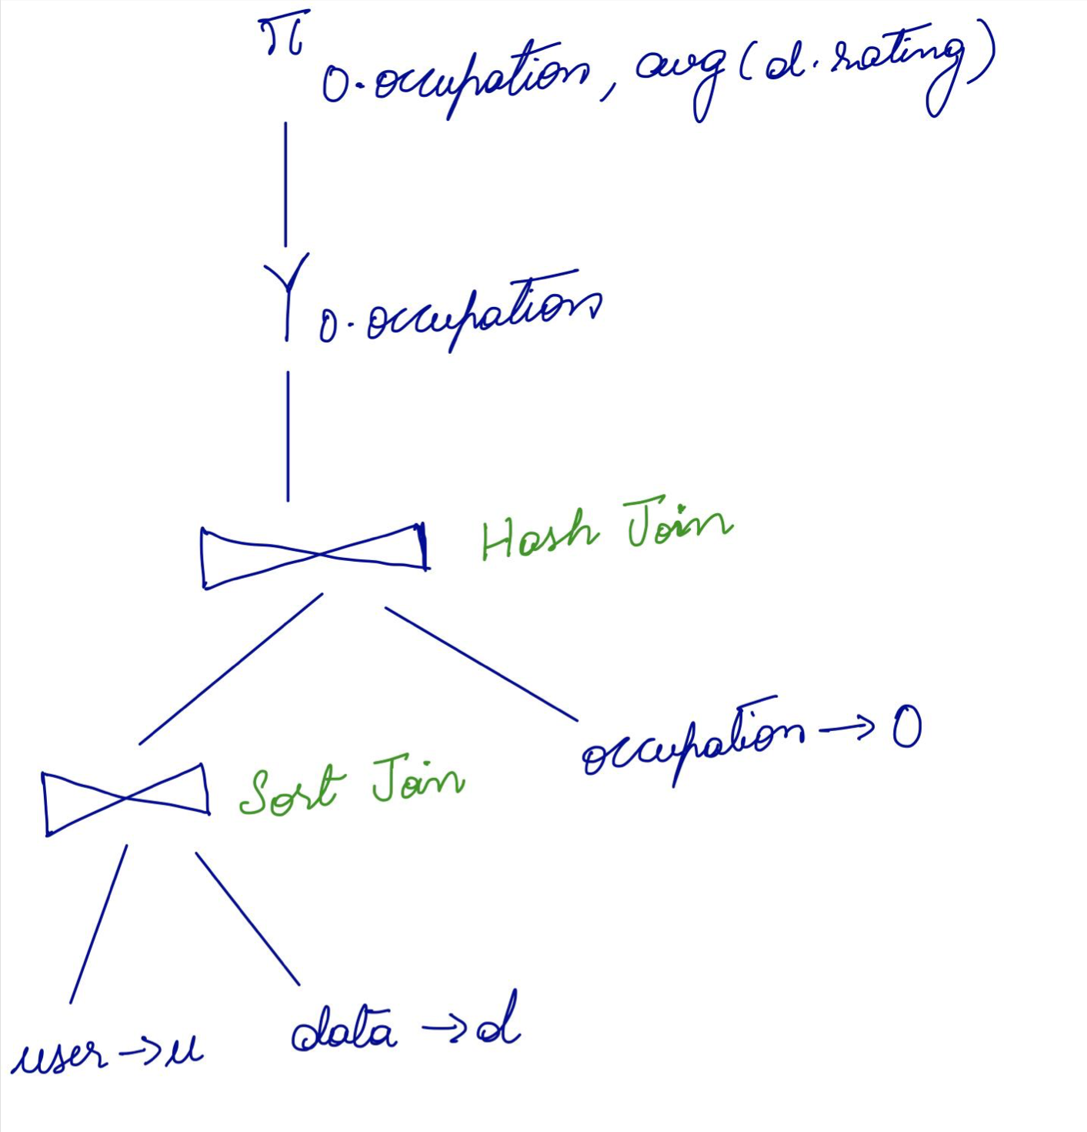**Our Explain Plan Oracle’s Explain Plan**

Query 7

***Number of ratings for movies released since Nicholas was born***

SELECT m.title, m.release_date, count(d.rating) AS num_ratings FROM movie m

INNER JOIN data d

ON d.itemid = m.movieid WHERE m.release_date >= '1996-06-29' GROUP BY m.title, m.release_date

**Result:**

**Rows fetched : 516**

**Oracle : 0.10 seconds Hive : 43.264 seconds**

Oracle and Hive query results

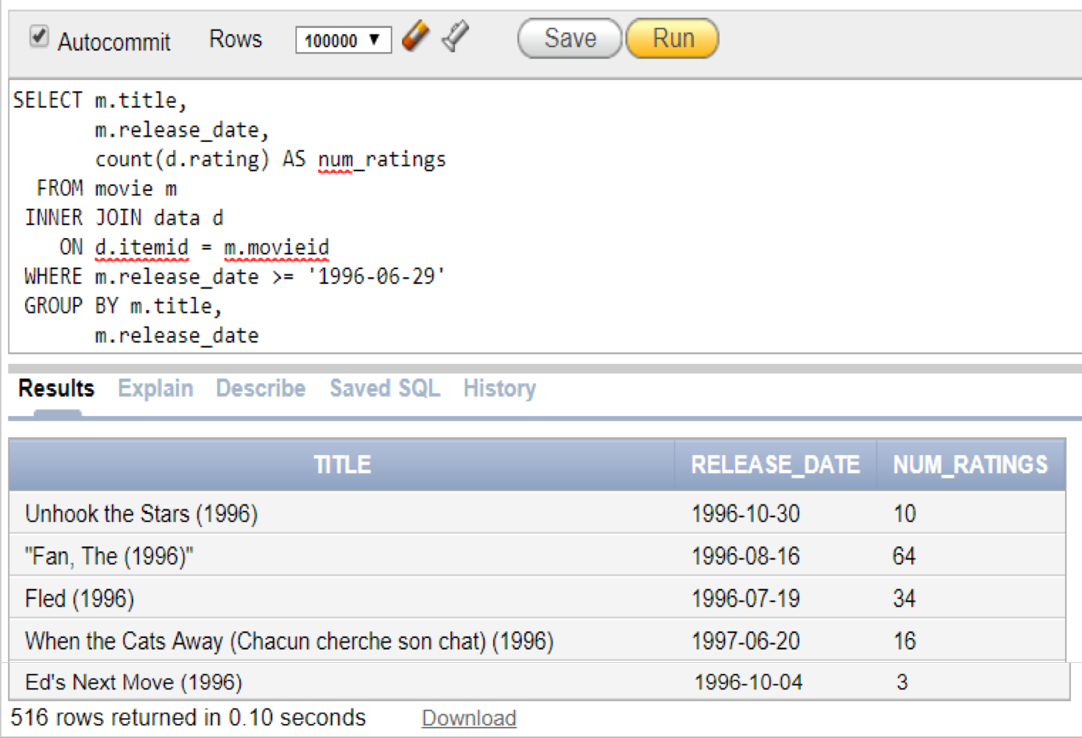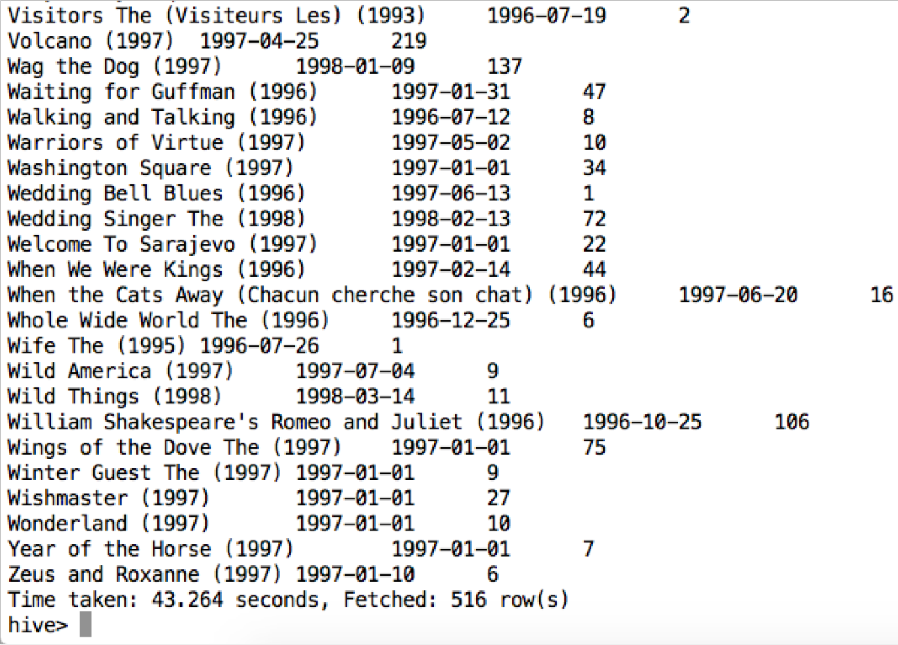

Oracle Explain plan

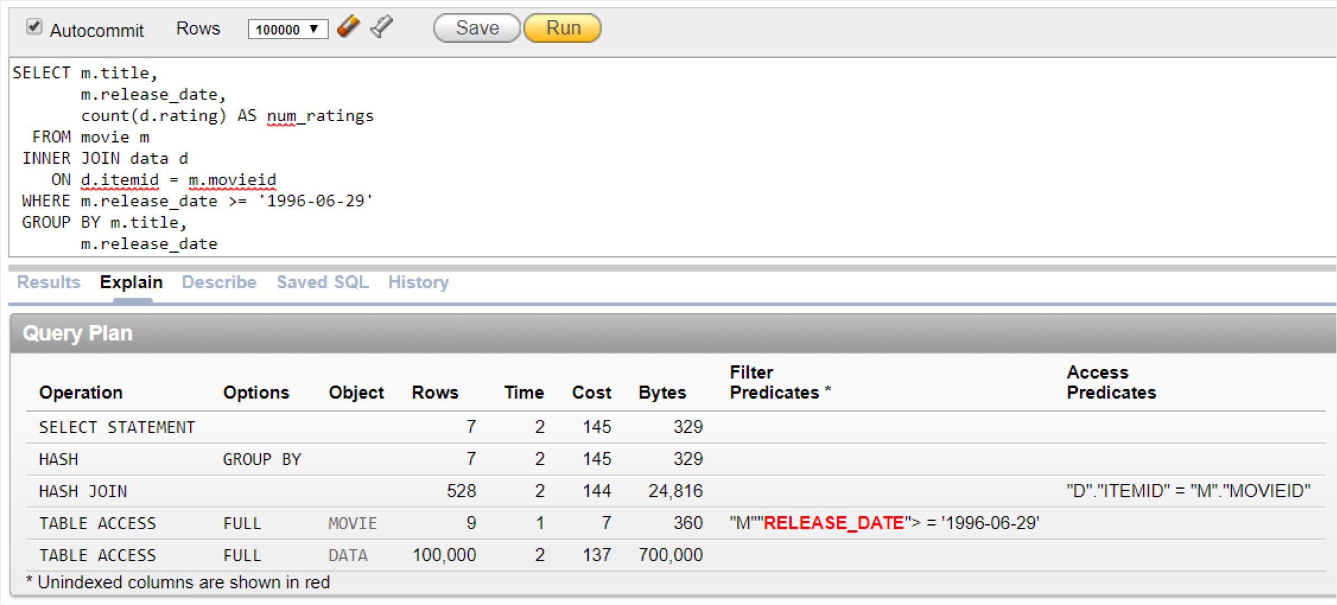

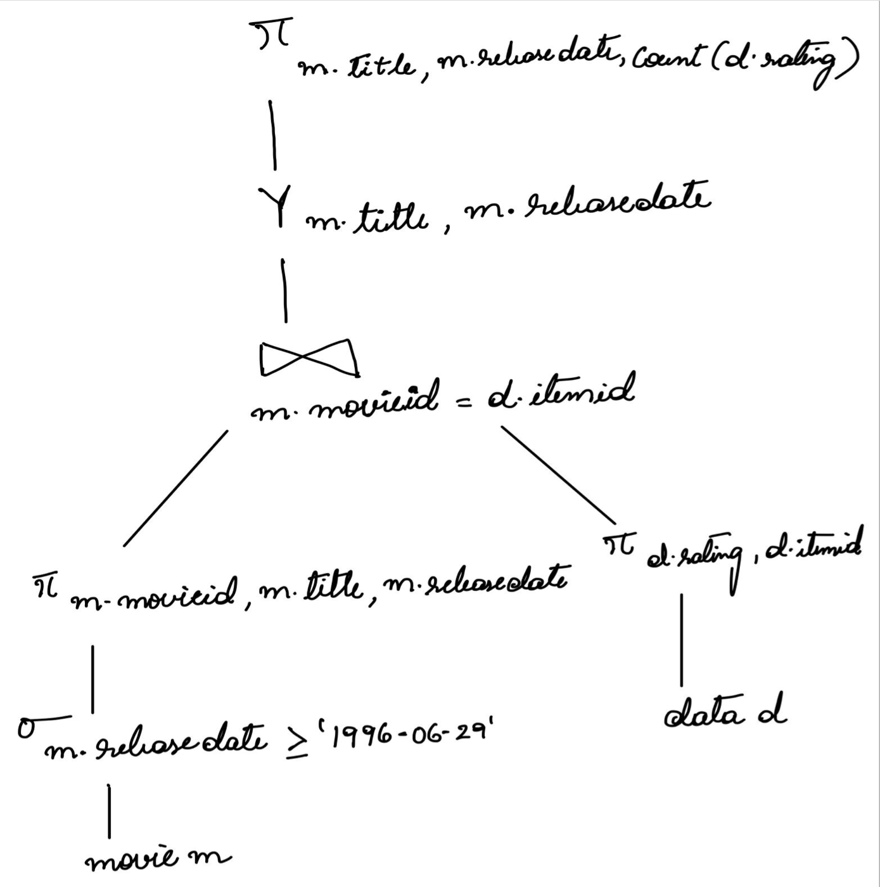**Our Explain Plan Oracle’s Explain Plan**

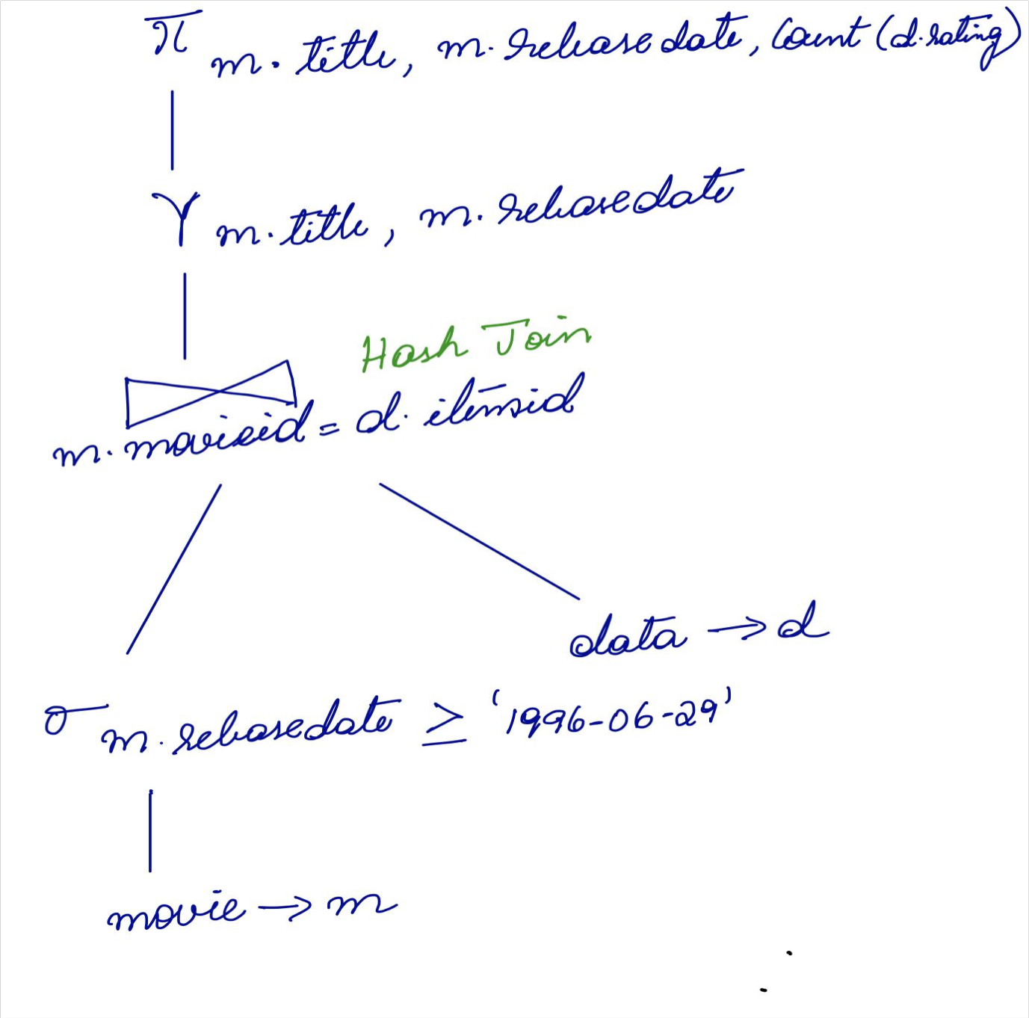

Query 8

***Select movies watched from users who live in Palo Alto and are not an engineer***

SELECT DISTINCT m.title

FROM movie m WHERE m.movieid IN (

SELECT d.itemid FROM data d WHERE d.userid IN (

SELECT u.userid FROM users u

WHERE u.occupationid IN ( SELECT o.occupationid FROM occupation o

WHERE o.occupation != 'engineer') AND u.zipcode IN (

SELECT z.zipcode

FROM zipcode z

WHERE z.city = 'PALO ALTO')))

**Result:**

**Rows fetched: 53 Oracle : 0.10 seconds Hive : 44.28 seconds**

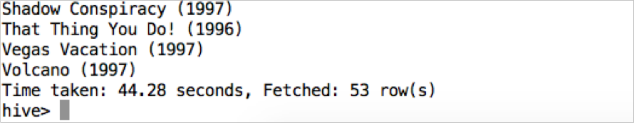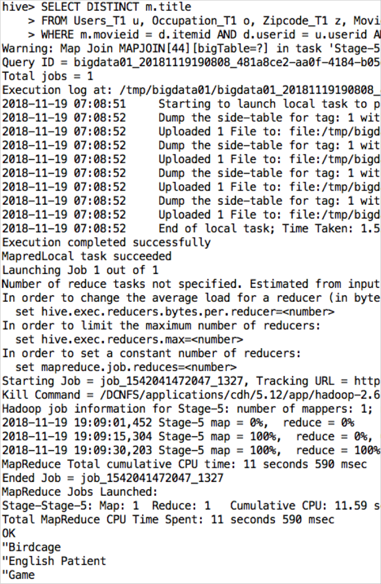Oracle and Hive query results

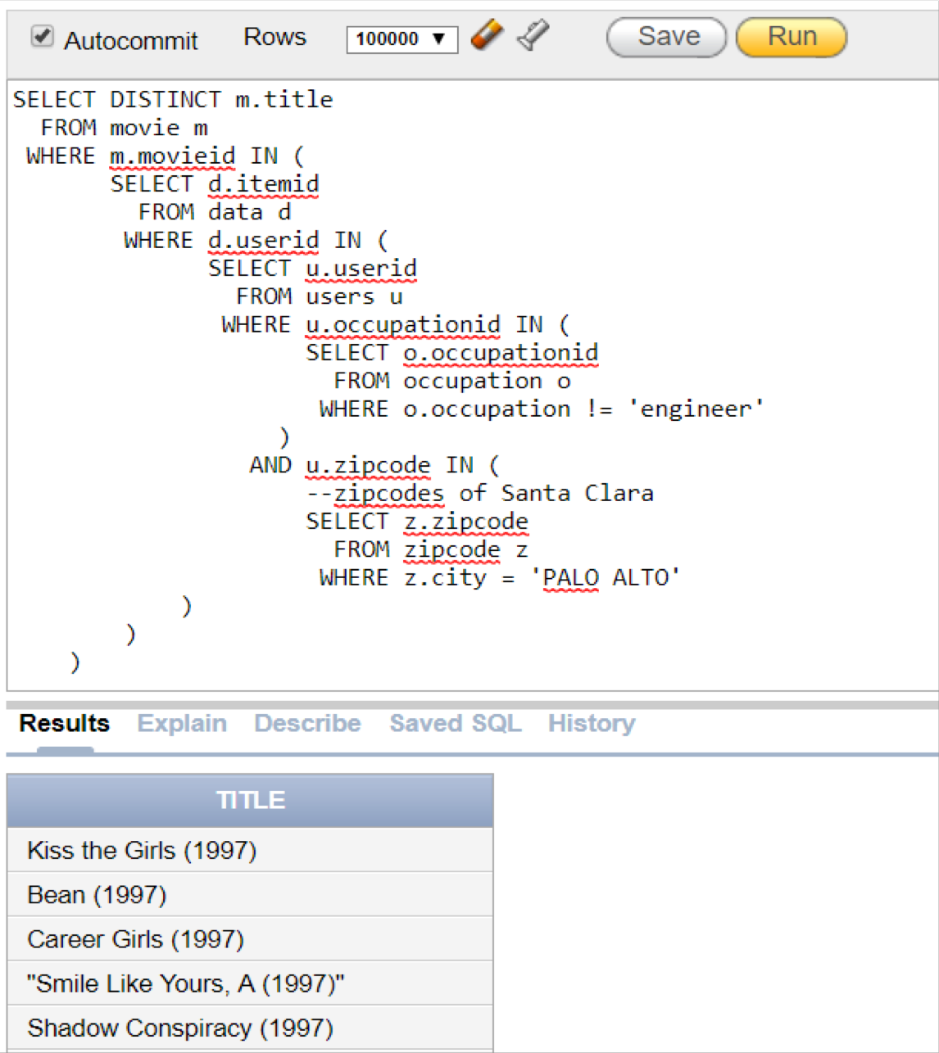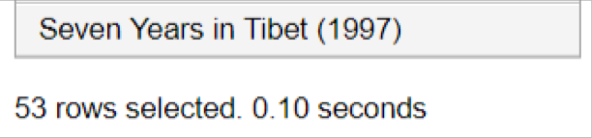

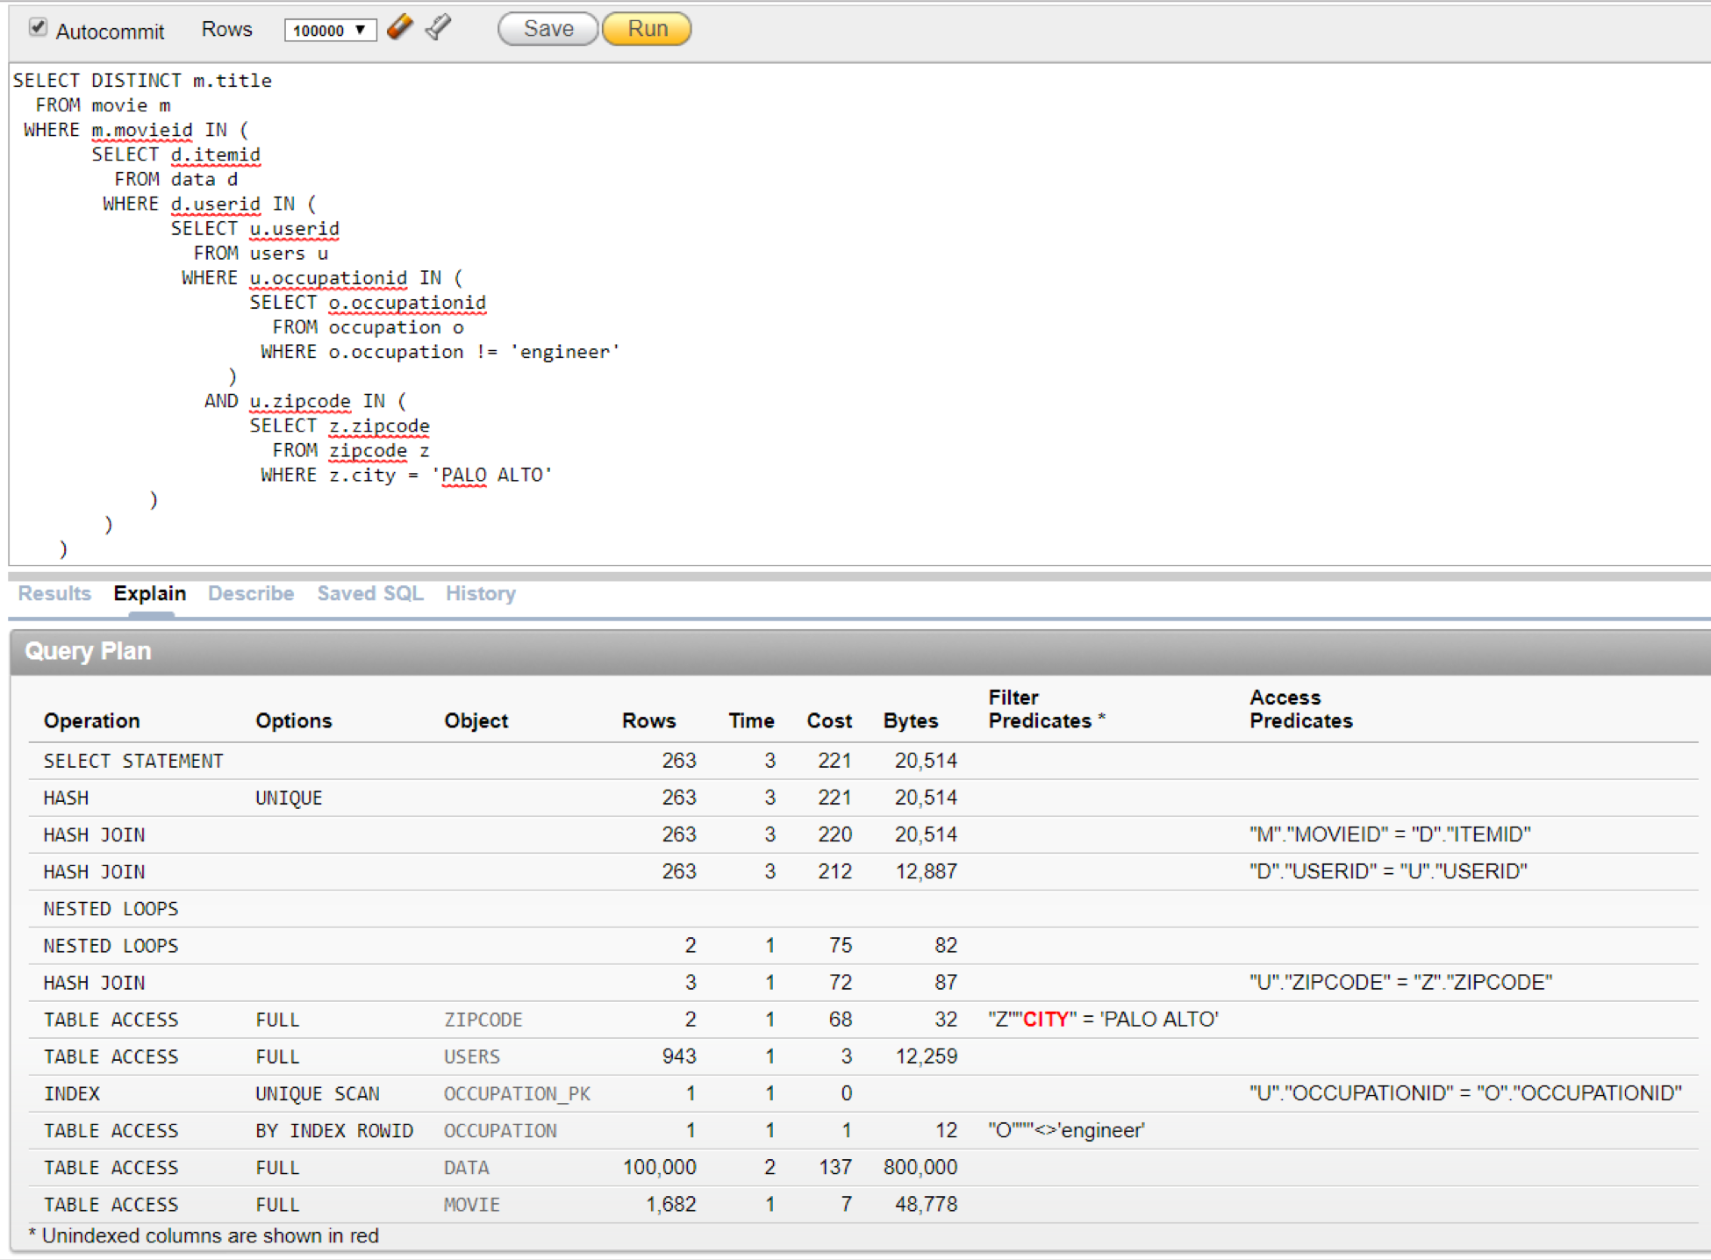Oracle Explain Plan for Query 8

**Our Explain Plan Oracle’s Explain Plan**

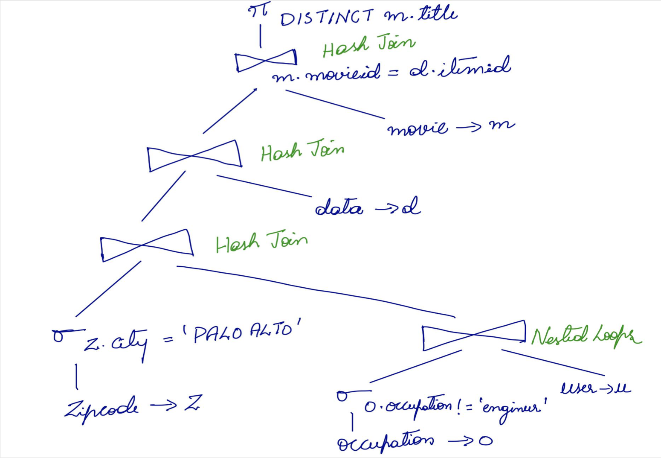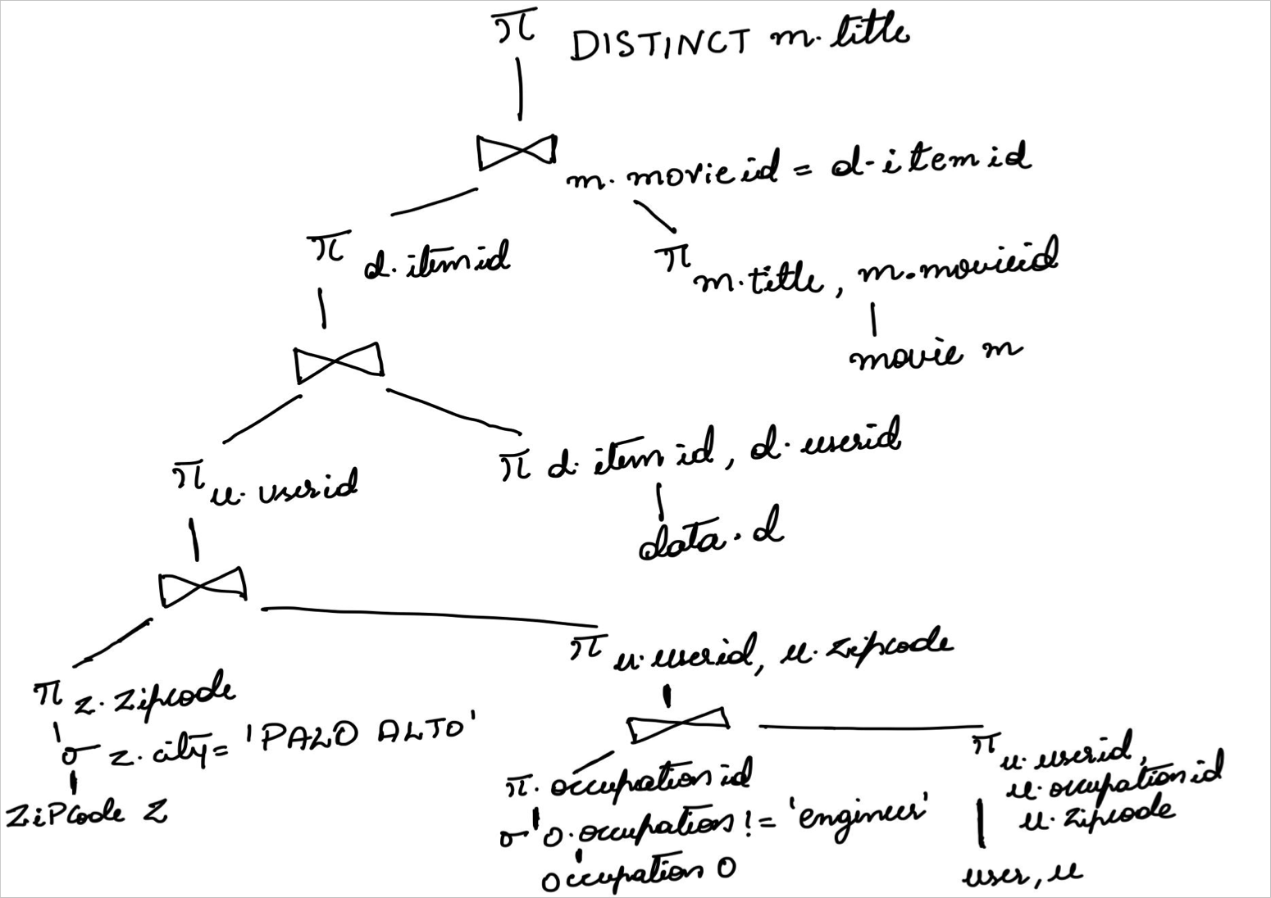

Conclusion: Oracle is faster than Hive

* Oracle uses index
* Data is small enough for Oracle to run efficiently
* Hive follows schema on read, better suited for large analytic processing
* Hive has to do shuffling of the data
* Hive has lots of overhead

Q&A

Thank You!!!